User Manual  
Of  
CodersTrust

Table Of Content

**Introduction** **5**

**1. Admin User** **6**

1.1 Login 6

1.2 Forgot Password 6

1.3 Dashboard 7

1.4 Course Management 7

1.4.1 Search Courses 7

1.4.2 Search Result 8

1.4.3 Sales Report 10

1.4.4 Course Rating 11

1.4.5 Add Course 12

1.5 Course Category 13

1.5.1 Category List 13

1.5.2 Create Category 14

1.5.3 Edit Category 15

1.6 Coupon Page 15

1.6.1 Coupon List 15

1.6.2 Create Coupon 16

1.6.3 Edit Coupon 18

1.7 Search User 19

1.7.1 User Searching Form 19

1.7.2 User Search Result 20

1.7.3 Instructor Sale Report 22

1.7.4 Add User 23

1.8 Tags Page 24

1.8.1 Tag List page 24

1.8.2 Create A Tag 25

1.8.3 Update A Tag 25

1.9 Email Template 26

1.9.1 Email Template List 26

1.9.2 Email Template Edit 26

1.10 Currencies 28

1.10.1 Currencies List 28

1.10.2 Add A Currency 29

1.10.3 Update A Currency 29

1.11 Faq Section 30

1.11.1 Faq Section List 30

1.11.2 Add A Faq Section 31

1.11.3 Update A Faq Section 32

1.12 Frequently Asked Questions 32

1.12.1 Faqs List 32

1.12.2 Add A FAQ 33

1.12.3 Update A FAQ 35

1.13 Badges 35

1.13.1 Badge List 35

1.13.2 Edit Badge 36

1.14 News 37

1.14.1 News List 37

1.14.2 Add A News 38

1.14.3 Update A News 40

1.15 Content Management 41

1.15.1 Home 41

1.16 Exam And Sales Report 43

1.16.1 Instructor Search 43

1.16.2 Exam Report 43

1.17 Course Report 44

1.17.1 Search Course 44

1.17.2 Search Course Result 45

1.18 Coupon Usages 45

1.18.1 Coupon Report 45

1.19 Export Report 46

1.19.1 Export Sales Report 46

1.20 Payment 47

1.20.1 Gateway 47

1.20.2 Create A Gateway 48

1.20.3 Update A News 49

1.21 Subscriber 50

1.21.1 Subscriber List 50

1.22 Help And Support 50

1.22.1 Supports 50

1.22.2 Ticket Details 51

1.23 Update A Course 52

1.23.1 Initial Setup 52

1.23.2 Overview Section 54

1.23.3 Exam Setup 58

1.23.4 Create New Chapter 59

1.23.5 Create Lesson 60

1.23.6 Create Test 61

1.23.7 Table Of Content 64

1.23.8 Q&A Section 65

1.24 Roles 67

1.24.1 Roles List 67

1.24.2 Add A Role 68

1.24.3 Update A Role 69

# Introduction

CodersTrust is a learning platform that provides a realistic environment where students learn new skills to enjoy financial success.

In this application, there are three types of users.

* **Unregistered users:** Unregistered users are those who did not register as students or instructors. But they can access some of the pages of the application.
* **Student:** Students are registered users of this application as a student.
* **Instructor:** Instructors are registered users of this application as an instructor.

# 1. Admin User

## 1.1 Login

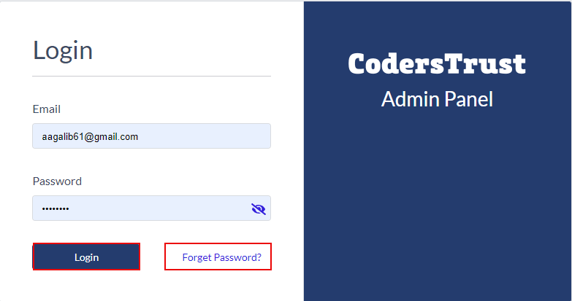

**Image- 1.1.1 Admin Login**

* Users must log in with their registered email and password if they have the admin's account. See **Image- 1.1.1.**
* Users must register for admin from the client panel if they don't have an account.
* Admin must click the “**Login**” button.
* After clicking the “**Login**” button, they redirect to the **Dashboard**
* If admins forget their password, they can click the “**Forget Password**.”
* After clicking the “**Forget Password**,” they will redirect to the Forget Password page.

## 1.2 Forgot Password

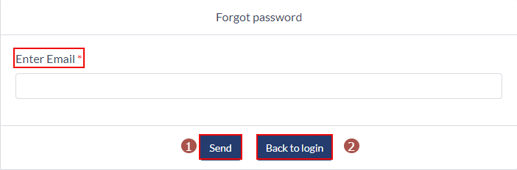

**Image- 1.2.1 Forgot Password**

* Admins have to provide their registered email in the email field.
* If they click the “**Send**” button, they will get a password reset link to their email.
* If they click the “**Back to Login**” page, they will redirect to the login page.
* If admins click the password reset link from their email, they will redirect to the password reset page.
* From the password reset page, admins can reset their passwords.

## 1.3 Dashboard

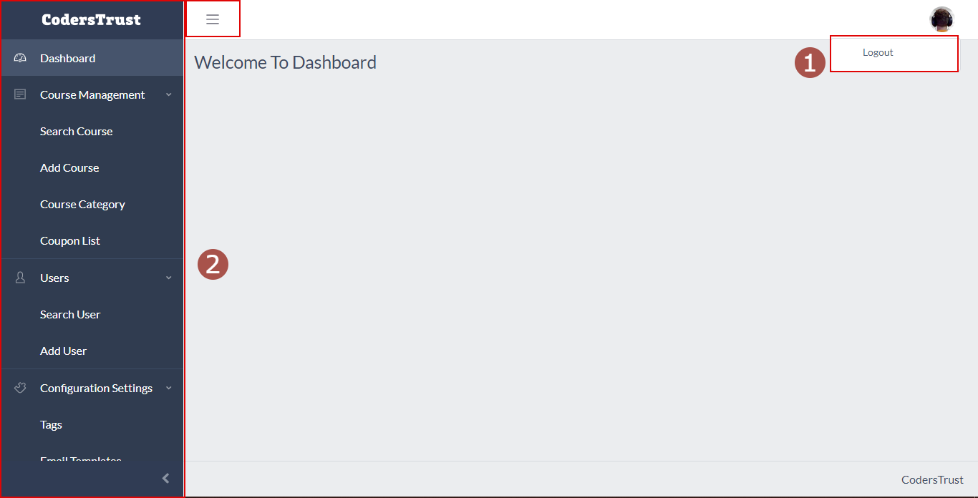

**Image- 1.3.1 Admin Dashboard**

* After successful login, admins will redirect to this page.
* Number 1 **in image- 1.3.1**, admins can log out by clicking the ”**Logout**” button.
* Number 2 **in the image- 1.3.1** is the navigation panel. Clicking any section admin will redirect to that page.

## 1.4 Course Management

### 1.4.1 Search Courses

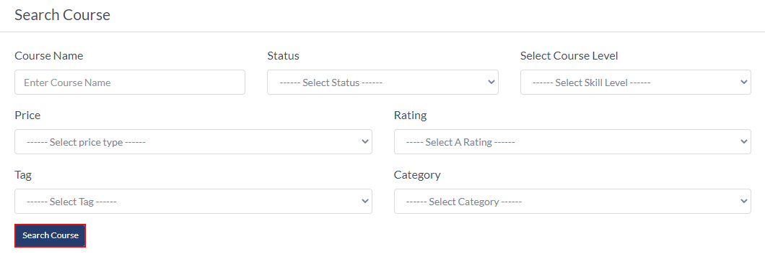

**Image- 1.4.1.1 Search Course Section**

* Admin can search courses by giving some parameters and filter courses by selecting some options; shown in **Image- 1.4.1.1**
* Admin can search without giving all parameters, but all the courses will be listed in the search result section for this case.
* Admins can search or filter any course by following parameters.
  + Course Name
  + Course Status
    - Draft
    - Published
    - Pending Review
    - Disapproved
    - Submission Canceled
  + Course Level
    - Beginner
    - Intermediate
    - Experts
  + Price
    - Paid
    - Fixed
  + Rating (0-5)
  + Tag
  + Category
* After giving all the parameters inputs, admins must click the “**Search Course**” button. And the result will appear in the Search Result section.

### 1.4.2 Search Result

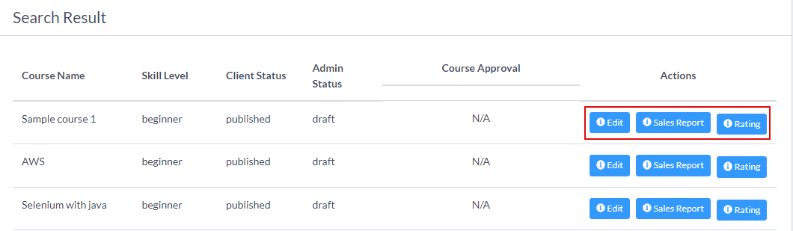

**Image- 1.4.2.1 Search Result Section**

* After clicking the “**Search Course**” button, the result will appear in this section.
* The section will have the following fields
  + Course Name
  + Skill level
  + Client Status. Admins can know what is the client status for this course.
    - Published
    - Draft
  + Admin Status. Admins can know this course's status from the admin panel.
    - Published
    - Draft
    - Pending Review
    - Rejected
    - Submission cancelled
  + Course Approval
    - Approve.
      * This button will only appear if the admin status is “Pending-Review”.
      * If admins click the “**Approve**” button, the course will be approved, and client users can see the course.
    - Disapprove.
      * This button will only appear if the admin status is “Pending-Review”.
      * If admins click the “**Disapprove**” button, the course will be rejected, and client users can not see the course.
    - Accept Request.
      * This button will only appear if the admin status is “Submission-Cancelled”.
      * If admins click the “**Accept Request**” button, the submission cancel request will be approved.
    - Reject Request.
      * This button will only appear if the admin status is “Submission-Cancelled”.
      * If admins click the “**Reject Request**” button, the submission cancel request will be rejected.
  + Actions
    - Edit. See 1.23 Update Course
    - Sales Report. See 1.4.3 Sales Report
    - Rating. See 1.4.4 Course Rating

### 1.4.3 Sales Report

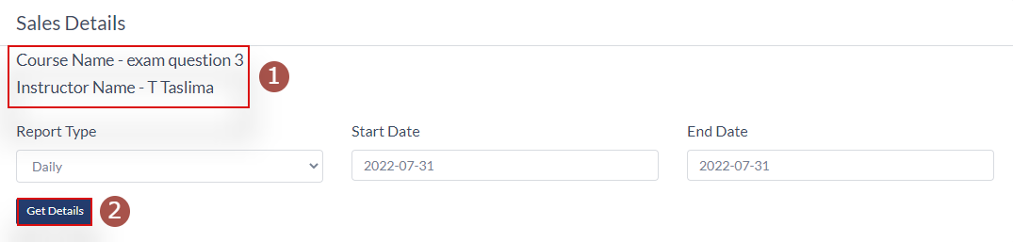

**Image- 1.4.3.1 Sales Details Section**

* After clicking the “**Sales Report**” button, shown in **Image- 1.4.2.1**, admins will redirect to this page.
* Number 1 in **Image- 1.4.3.1,** admins can see the course name and instructor’s name of the report.
* They can filter and search courses by following fields
  + Report Time
    - Daily, this will show a report of any particular date.
    - Monthly, this will show a report of any particular month.
    - Yearly, this will show a report of any particular year.
  + Start Date
  + End Date
* Admins must click the “**Get Details**” button to get the result, shown in number 2 in **Image- 1.4.3.1.**

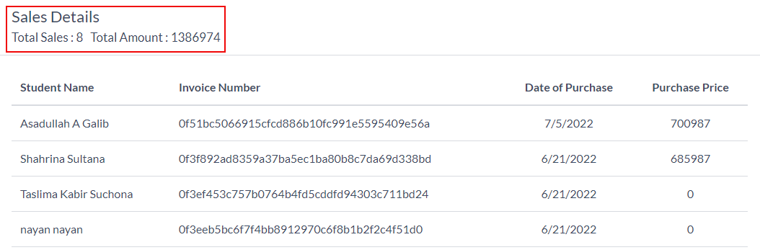

**Image- 1.4.3.2 Sales Result Section**

* In this section, admins can see the following details of the course
  + Students Name
  + Invoice Number
  + Date of Purchase
  + Purchase Amount

### 1.4.4 Course Rating

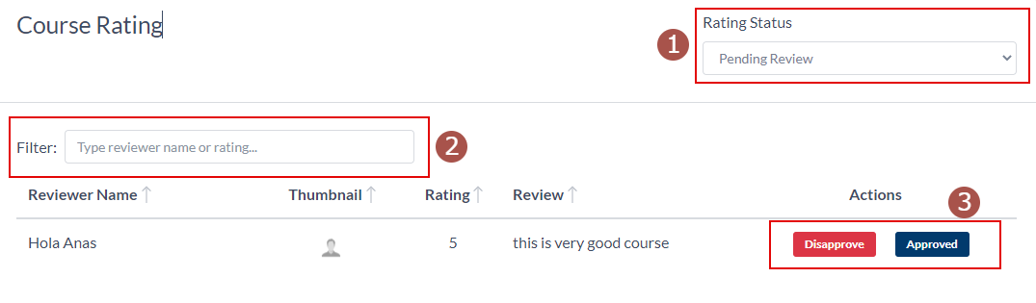

**Image- 1.4.4.1 Course Rating Section**

* After clicking the “**Rating**” button, shown in **Image- 1.4.2.1**, admins will redirect to this page.
* Number 1 in **Image- 1.4.4.1**, admin can filter course ratings by following options.
  + Published
  + Pending Review
  + Rejected
* Number 2 in **Image- 1.4.4.1**, admin can search by reviewer name
* In the search result, admins can see the following information.
  + Reviewer Name
  + Thumbnail
  + Course Rating
  + Course Review
  + Actions
    - Disapprove; clicking this button will not publish the review.
    - Approve; clicking this button will publish the review.

### 1.4.5 Add Course

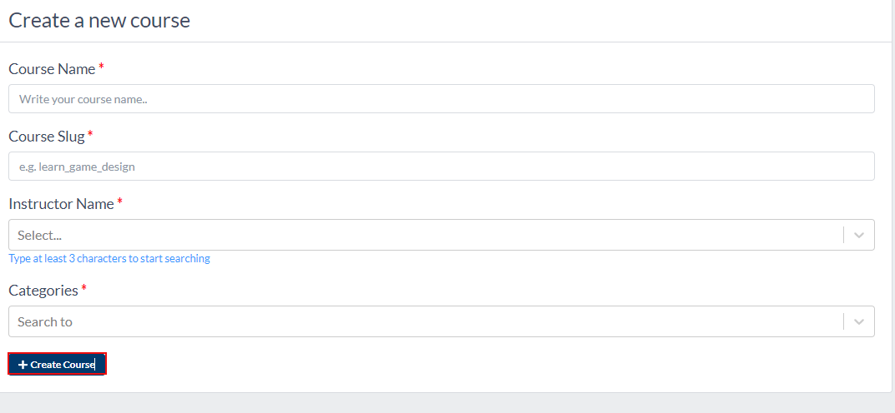

**Image- 1.4.4.1 Course Create Section**

* Admins can create any course from this page from the admin panel, shown in **Image- 1.4.4.1.**
* For creating any course, admins must provide the following information.
  + **Course Name**
  + **Course Slug** will automatically fill this field while admins type the course name. But the admin can also edit the slug separately, which will be a course link.
  + **Instructor Name**: Admins must type at least three characters of the instructor’s name. If any instructor is available with those characters, it will appear, and they must select one instructor from the list.
  + **Category:** admins must select at least one category for the course, and they can choose a maximum of three categories.
* Admins must click the “**Create Course**” button to create the course. And a pop-up window will appear to confirm the slug, shown in **Image- 1.4.4.2.**

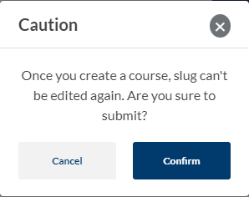

**Image- 1.4.4.2 Slug Confirmation**

* Once the course is created, the slug can never be changed further.
* Clicking the “**Confirm**” button will create the course.
* Clicking the “**Cancel**” button will remain on the create course page.

## 1.5 Course Category

### 1.5.1 Category List

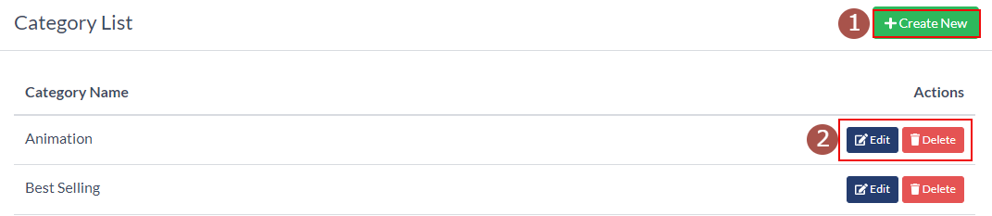

**Image- 1.5.1.1 Category List**

* All the categories will be listed on this page.
* Admins can see the following information from this page.
  + Admins can create a new category by clicking the “**Create New**” button. See number 1 in **Image- 1.5.1.1**
  + Category Name
  + Actions, shown in number 2 in **Image- 1.5.1.1**
    - **Edit category**. See 1.5.3 Edit Category
    - **Delete Category**. By clicking this button, that category will be deleted.

### 1.5.2 Create Category

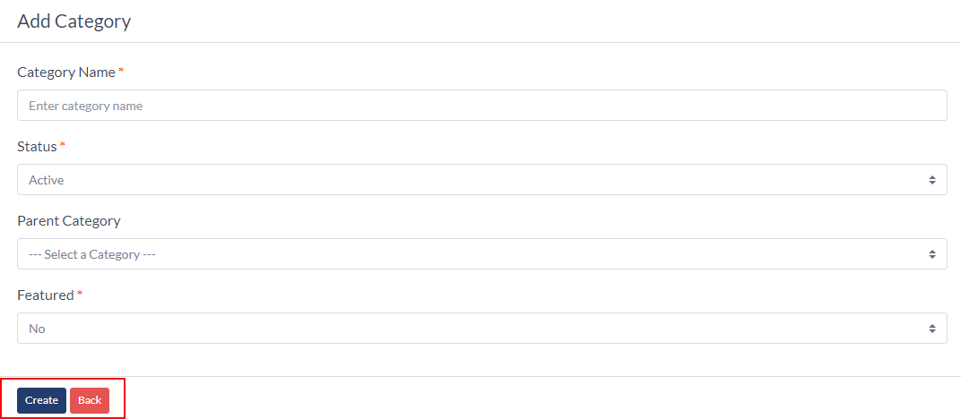

**Image- 1.5.2.1 Category List**

* After clicking the “**Create New**” button, admins will redirect to this page. See number 1 in **Image- 1.5.1.1.**
* Admins have to provide the following information for creating a category.
  + Category Name
  + Category Status
    - **Active**
    - **Inactive**
  + Parent Category
  + Featured
    - **Yes**
    - **No**
* Clicking the “**Create**” button will create the category.
* Clicking the “**Back**” button will redirect to the category list page.

### 1.5.3 Edit Category

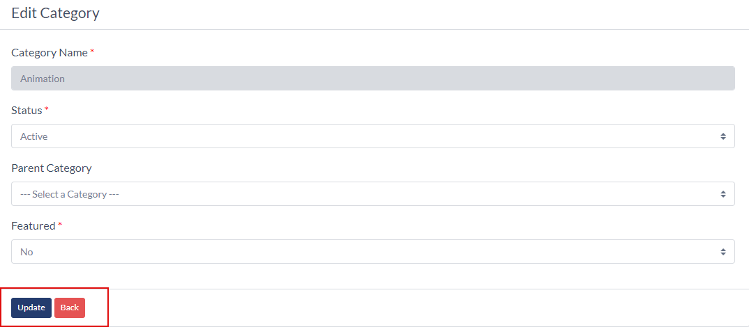

**Image- 1.5.3.1 Category List**

* After clicking the “**Edit**” button, admins will redirect to this page. See number 2 in **Image- 1.5.1.1.**
* All the previous data will be pre-filled.
* Admins can not change the Category Name.
* Admins have to update the following information.
  + Category Status
    - **Active**
    - **Inactive**
  + Parent Category
  + Featured
    - **Yes**
    - **No**
* Clicking the “**Create**” button will create the category.
* Clicking the “**Back**” button will redirect to the category list page.

## 1.6 Coupon Page

### 1.6.1 Coupon List

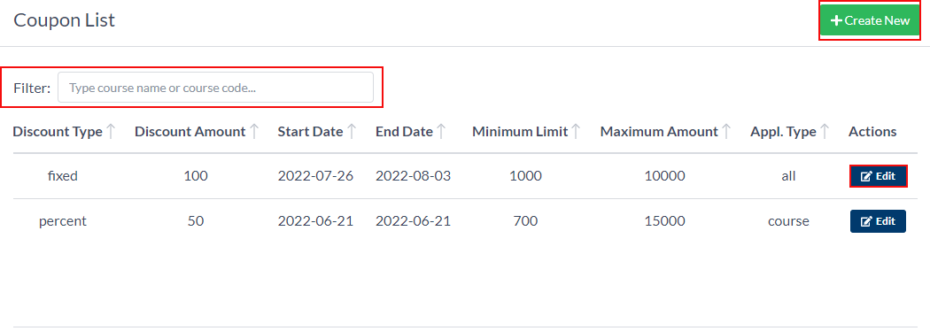

**Image- 1.6.1.1 Coupon List**

* All the coupons will be listed on this page.
* Admins can see the following information from this page.
  + Admins can create a new coupon by clicking the “**Create New**” button.
  + Coupon Code
  + Course Name
  + Status
  + Number of times applied coupon
  + Discount Type
  + Discount Amount
  + Start Date
  + End Date
  + Minimum Limit
  + Maximum Limit
  + Appl. Type
  + Actions
    - **Edit Coupon**. See 1.6.3 Edit Coupon

### 1.6.2 Create Coupon

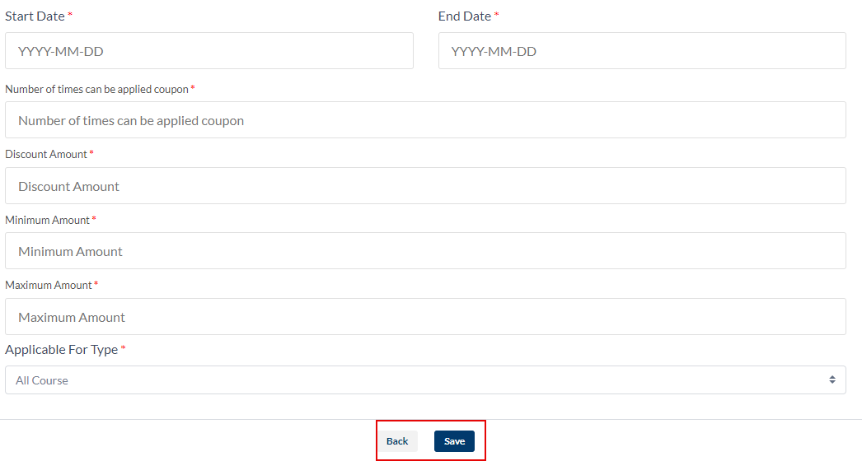

**Image- 1.6.2.1 Create Coupon**

* After clicking the “**Create New**” button, admins will redirect to this page. Shown in **Image- 1.6.1.1.**
* Admins have to provide the following information for creating a coupon.
  + Coupon Code
  + Coupon Status
    - **Active** means the coupon is active for the client’s usage.
    - **Inactive** means the coupon is deactivated for the client's usage.
  + Discount Type
    - **Fixed.** It will give some fixed amount of discount on the course price.
    - **Percentage.** It will give a percentage discount on the course price.
  + Started Date
  + End Date
  + The number of times the coupon can be applied.
  + Discount amount
  + Minimum amount
  + Maximum amount
  + Applicable For Type
    - **All Courses**. The coupon will be applicable for all the courses.
    - **Course Wise**. The coupon will be applicable for a particular course, and selecting this option will appear in another field for choosing a course.
* Clicking the “**Create**” button will create the coupon.
* Clicking the “**Back**” button will redirect to the coupon list page.

### 1.6.3 Edit Coupon

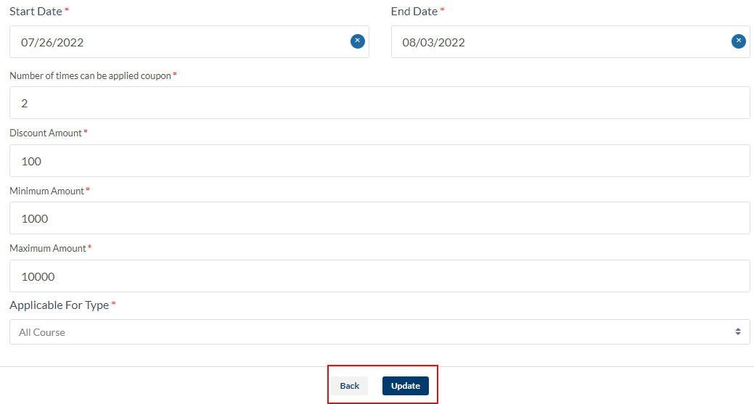

**Image- 1.6.3.1 Edit Coupon**

* After clicking the “**Edit**” button, admins will redirect to this page.
* All the previous data will be pre-filled.
* Admins can update the following fields.
  + Coupon Code
  + Coupon Status
    - **Active** means the coupon is active for the client’s usage.
    - **Inactive** means the coupon is deactivated for the client's usage.
  + Discount Type
    - **Fixed.** It will give some fixed amount of discount on the course price.
    - **Percentage.** It will give a percentage discount on the course price.
  + Started Date
  + End Date
  + The number of times the coupon can be applied.
  + Discount amount
  + Minimum amount
  + Maximum amount
  + Applicable For Type
    - **All Courses**. The coupon will be applicable for all the courses.
    - **Course Wise**. The coupon will be applicable for a particular course, and selecting this option will appear in another field for choosing a course.
* Clicking the “**Update**” button will update the coupon.
* Clicking the “**Back**” button will redirect to the coupon list page.

## 1.7 Search User

### 1.7.1 User Searching Form

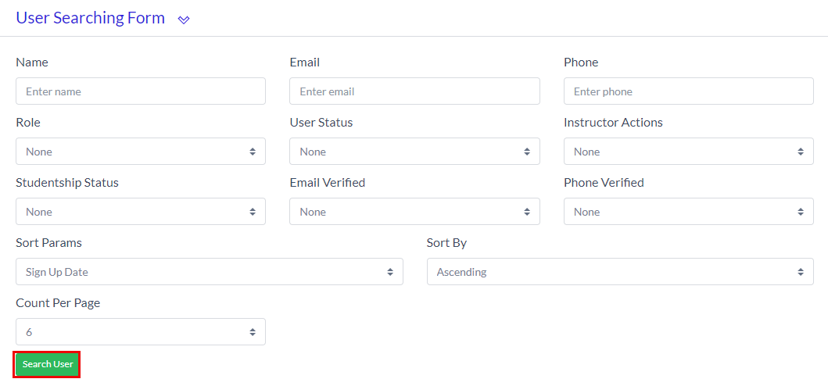

**Image- 1.7.1.1 User Searching Form**

* Admins can search users from this page. Shown in **Image- 1.7.1.1.**
* They can search or filter users using parameters or without any parameters.
* They can search or filter users using the following parameters.
  + User’s Name
  + User’s Email
  + Phone number
  + User’s Role
    - **None**. Selecting **None** will have no effect on search results.
    - **Admin.** This will bring a list of all admins.
    - **Instructor.** This will bring a list of all instructors.
    - **Student.** This will bring a list of all students.
    - **Facebook Login User.** This will bring a list of all Facebook login users.
    - **Google Login User.** This will bring a list of all google login users.
    - **Linkedin Login User**. This will bring a list of all Linkedin login users.
  + User Status
    - **None**. Selecting **None** will have no effect on search results.
    - **Deleted.** This will bring a list of deleted users.
    - **Activated.** This will bring a list of active users.
  + Instructor Actions
    - **None**. Selecting **None** will have no effect on search results.
    - **Approval Pending**. A list of instructors whose approval is pending
    - **Approved**. Instructors whose approval is authorised.
    - **Blocked**. Instructors who are blocked.
  + Studentship Status
    - **None**. Selecting **None** will have no effect on search results.
    - **Activated.** This will bring a list of current students.
    - **Blocked.** Students who are blocked.
  + Email Verified
    - **None**. Selecting **None** will have no effect on search results.
    - **Yes**
    - **No**
  + Phone Verified
    - **None**. Selecting **None** will have no effect on search results.
    - **Yes**
    - **No**
  + Sort Params
    - **Sign Up Date**
    - **Total Bought Courses**
    - **Total Spent**
  + Sort By
    - **Ascending.** This will show the list in ascending order.
    - **Descending.** This will show the list in descending order.
  + **Current Per Page**. Admins can change how much data they want to see.
  + Admins must click the “**Search User**” button to get the user list results.

### 1.7.2 User Search Result

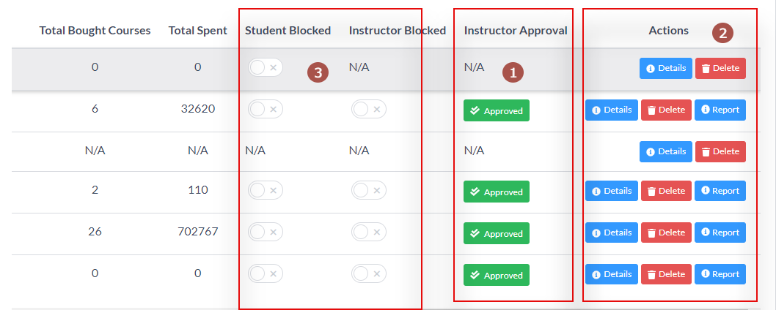

**Image- 1.7.2.1 User Searching Form**

* This is the user search result section. Shown in **Image- 1.7.2.1.**
* This section has the following information.
  + Name
  + Role
  + Phone
  + Email
  + Member Since
  + Total Bought Course
  + Total Spent
  + Student Blocked
  + Instructor Blocked
  + Instructor approval
    - **Approve**
    - **Disapprove**
  + Actions
    - **Details**
    - **Delete**
    - **Report.** This button will only appear if the user approves for instructor's approval.
* Admin can block or unblock any students and instructors from this section, as shown in number 3 in **Image- 1.7.2.1.**

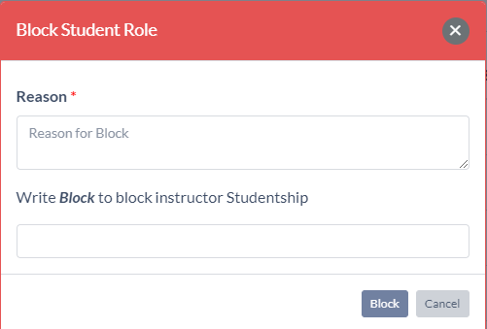

**Image- 1.7.2.2 User Block Form**

* + After clicking the button, the above pop-up window will open, as shown in **Image- 1.7.2.2.**
  + Admins must provide the reason for blocking the students and instructors. And type the “**Block**” word.
  + Clicking the “**Block**” button, the users will block, and they will not log in to the system with their credentials.
  + Clicking the “**Cancel**” button will cancel the block.
* If users apply for the instructor role, there will be two buttons in the instructor approval column, as shown in **Image- 1.7.2.1.**
  + **Approve.** It will approve the instructor's request.
  + **Disapprove.** It will cancel the instructor's request.
* In the action column, there will be three buttons.
  + **Details.** Clicking this button will open a pop-up window and show the user profile in **Image- 1.7.2.3.** There will be the following information.
    - User name
    - User Role
    - Email
    - Student Status
    - Instructor Status

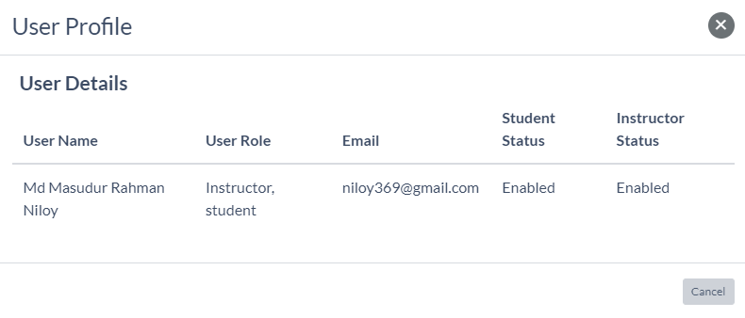

**Image- 1.7.2.3: User Profile**

* + **Delete**; clicking this button will delete the user from the system.
  + **Report**, clicking this button will redirect to the report page. This button will only appear if the admins approve the instructor. See 1.7.3 Instructor Sales Report.

### 1.7.3 Instructor Sale Report

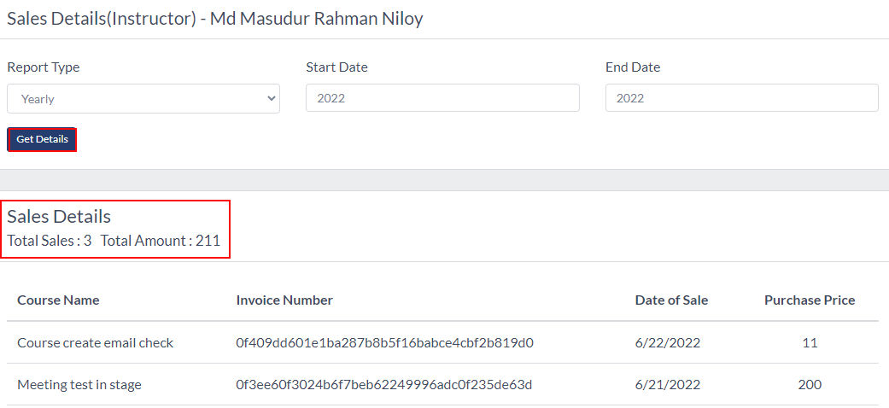

**Image- 1.7.3.1 Instructor Sales Report**

* After clicking the “**Report**” button from number 2 in **Image- 1.7.2.1,** admins will redirect to this page.
* Admins can see individual instructor’s sales reports from here.
* Admins have to provide the following data.
  + Report Type
    - Daily
    - Monthly
    - Yearly
  + Start Date
  + End Date
* They must click the “**See Details**” button to see the report
* In the result section, shown in **Image- 1.7.3.1,** admins can see the summary of the instructor’s report.
  + Total sales
  + Total Amount
* In the report section, admins can see the following information.
  + Course Name
  + Invoice Number
  + Date Of Sale
  + Purchase Price

### 1.7.4 Add User

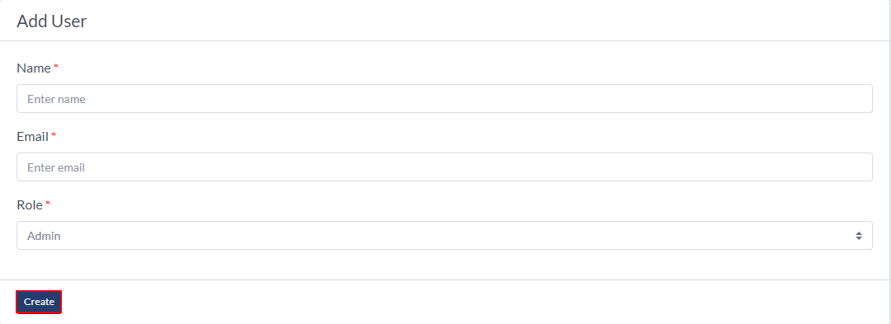

**Image- 1.7.4.1 Instructor Sales Report**

* Admins can add a user to the system.
* For that, they need to provide the following information.
  + User Name
  + User Email
  + User Role
    - Admin
* Admins must click the “**Create**” button to create a user.

## 1.8 Tags Page

### 1.8.1 Tag List page

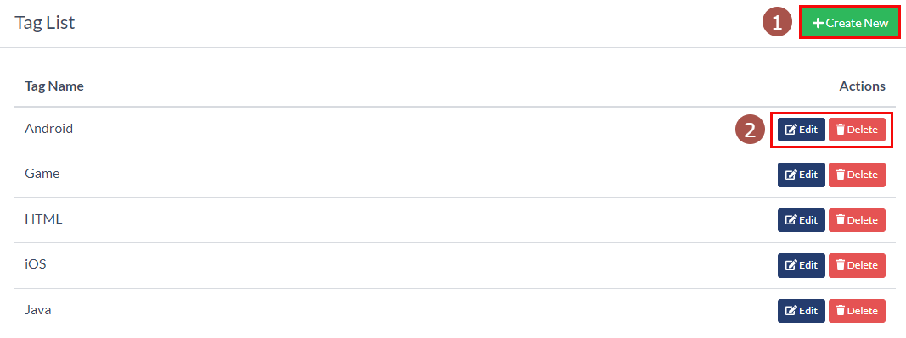

**Image- 1.8.1.1 Tag List Page**

* This is the Tag list page; all the tags will be listed here.
* Admins can create a tag by clicking the “**Create New**” button, shown in number 1 in **Image- 1.8.1.1.** See 1.8.2 Create A Tag
* Admins can edit a tag by clicking the “**Edit**” button, shown in number 2 in **Image- 1.8.1.1.** See 1.8.3 Update A Tag
* They can delete a tag by clicking the “**Delete**” button. A pop-up window will appear for confirmation to delete that tag, and they must click the “**Ok**” button.
* The above photo is the section in the client panel that will show the list, shown in **Image- 1.8.1.2.**

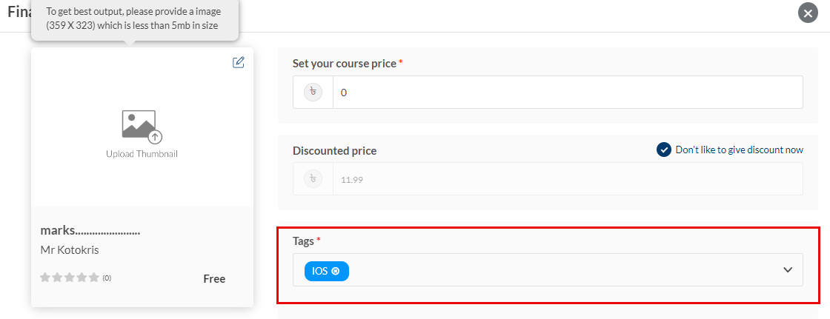

**Image- 1.8.1.2 Tag Shown In Client**

### 1.8.2 Create A Tag

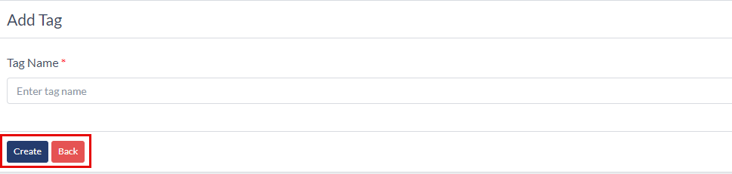

**Image- 1.8.2.1 Create A Tag**

* After clicking the “**Create New**” button, admins will redirect to this page, shown in number 1 in **Image- 1.8.1.1.**
* Admin must provide the “**Tag Name**” to create a tag.
* They must click the “**Create**” button. Then this tag will be added to the tag list page.
* Clicking the “**Back**” button will redirect to the tag list page.

### 1.8.3 Update A Tag

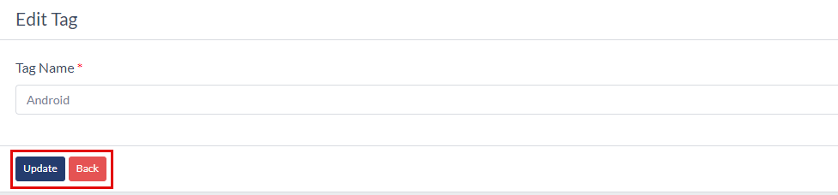

**Image- 1.8.2.1 Create A Tag**

* After clicking the “**Edit**” button, admins will redirect to this page, shown in number 2 in **Image- 1.8.1.1.**
* The tag name will be auto-filled.
* Clicking the “**Update**” button will update the tag name
* Clicking the “**Back**” button will redirect them to the tag list page.

## 1.9 Email Template

### 1.9.1 Email Template List

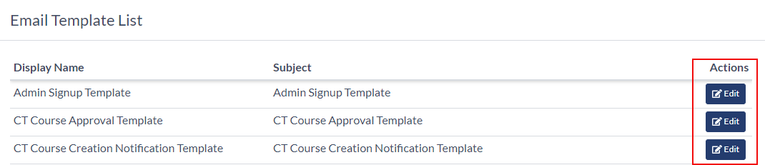

**Image- 1.9.1.1 Email Template List Page**

* All the email templates will be listed here on this page, shown in **Image- 1.9.1.1.**
* On this page, admins can see the following information about the email template.
  + Display Name
  + Subject
* If admins click the “**Edit**” button, they will redirect to the Template Edit page.

### 1.9.2 Email Template Edit

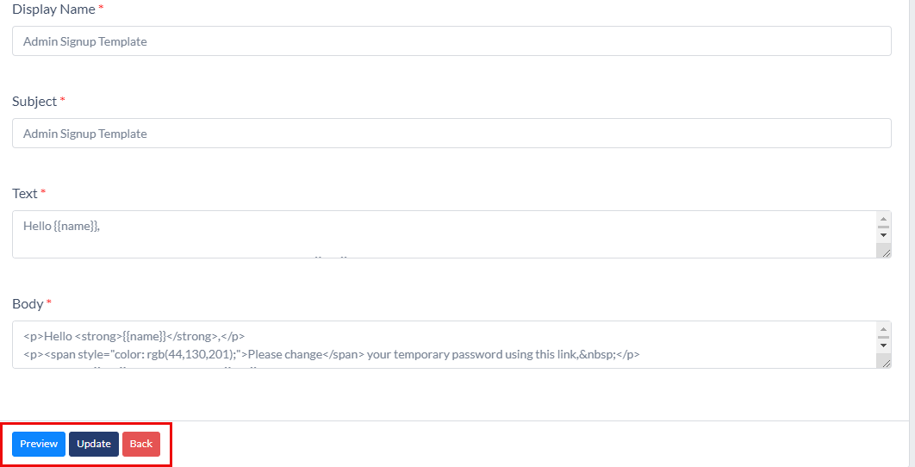

**Image- 1.9.2.1 Email Template Edit Page**

* After clicking the “**Edit**” button, admins will redirect to this page, Shown in **Image- 1.9.2.1.**
* Admins can edit the following fields.
  + Display Name
  + Subject
  + Text
  + Body
* Admins must not edit the inside content of curly braces “**{{}}**” content. That must be the same as before.
* If admins edit the content of curly braces “**{{}}**”, that will harm sending the mail. So it is suggested to the admins not to touch the content inside “**{{}}**”.
* There will be three buttons on the edit page.
  + **Update,** clicking this button will update the email template.
  + **Back,** Clicking this button will redirect the admins to the template list page.
  + **Preview,** if admins click this button, they will see the email preview.

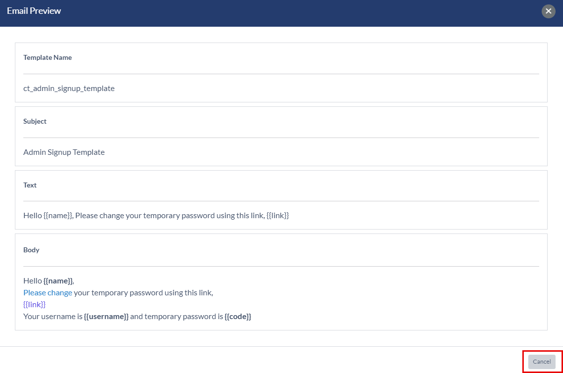

**Image- 1.9.2.2: Email Preview**

* If admins click the “**Cancel**” button, they will redirect to the edit page.

## 1.10 Currencies

### 1.10.1 Currencies List

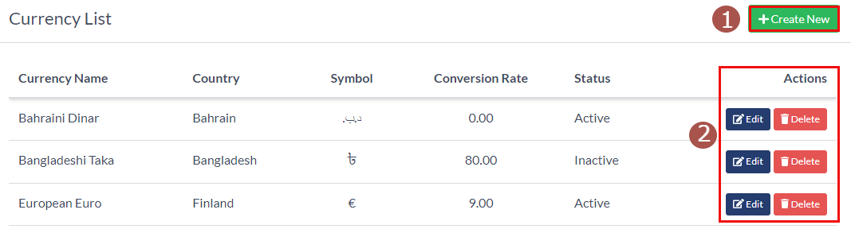

**Image- 1.10.1.1 Currencies List Page**

* All the currencies will be listed here, shown in **Image- 1.10.1.1.**
* Admins can see the following information.
  + Currency Name
  + Country
  + Symbol
  + Conversion Rate
  + Status
  + Actions
    - **Edit,** clicking this button will redirect to the Edit page. See 1.10.3 Update A Currency
    - **Delete;** clicking this button will delete that currency and open a confirmation pop-up window. Admins must click the “**Ok**” button to delete it.

### 1.10.2 Add A Currency

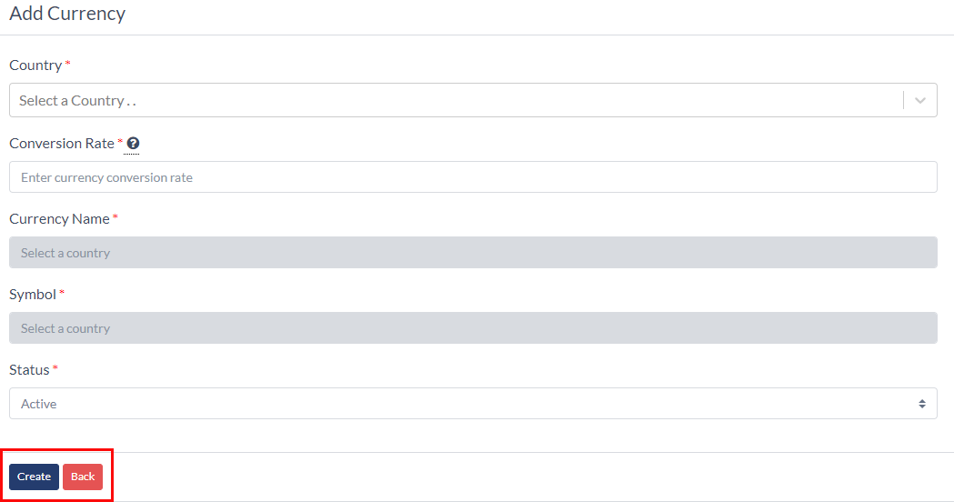

**Image- 1.10.2.1 Add A Currency**

* Admins must provide the following information to add a currency.
  + Country
  + Conversion Rate
  + Currency Name
  + Symbol
  + Status
    - Active
    - Inactive
* The currency will be created if admins click the “**Create**” button.
* Clicking the “**Back**” button will redirect them to the list page.

### 1.10.3 Update A Currency

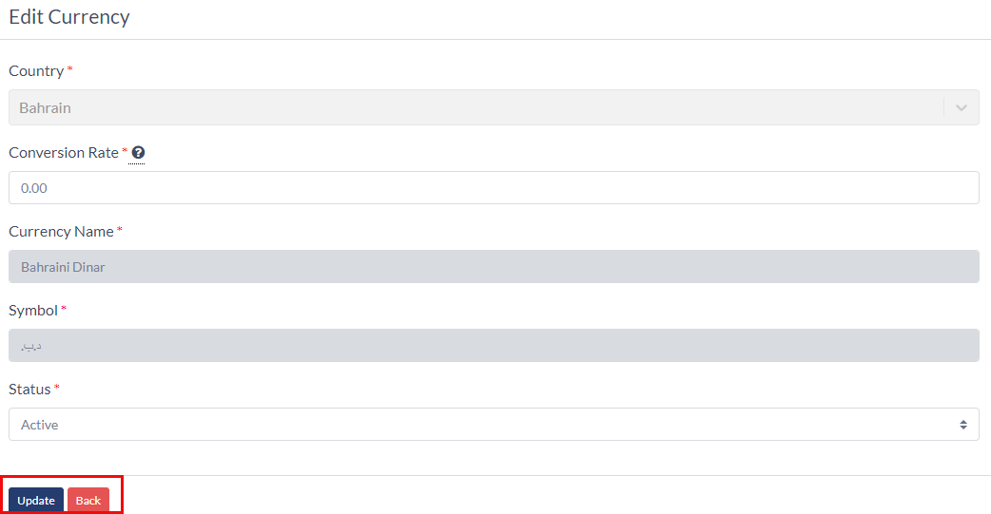

**Image- 1.10.3.1 Add A Currency**

* Admins can edit the following information about a currency.
  + Country
  + Conversion Rate
  + Currency Name
  + Symbol
  + Status
    - Active
    - Inactive
* The currency will be created if admins click the “**Update**” button.
* Clicking the “**Back**” button will redirect them to the list page.

## 1.11 Faq Section

### 1.11.1 Faq Section List

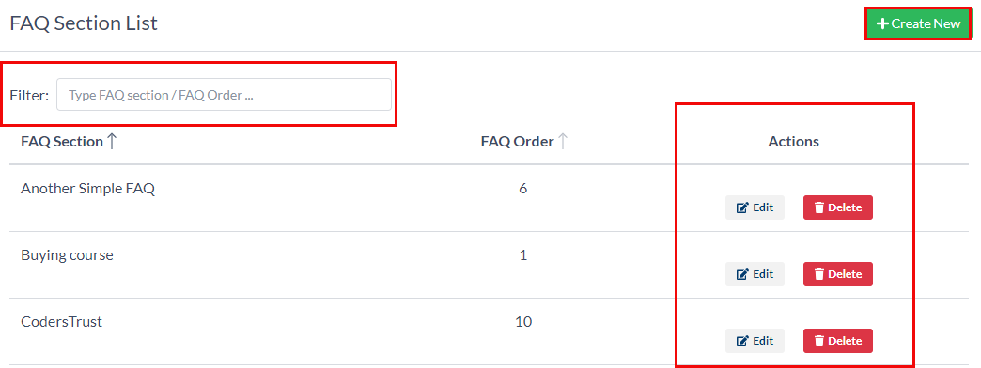

**Image- 1.11.1.1 Faq Section Page**

* All the FAQ Sections will be listed here, shown in **Image- 1.11.1.1.**
* Admins can create a Faq Section by clicking the “**Create New**” button.
* They can filter Faq Section by Faq Section Name and order.
* Admins can see the following information.
  + Faq Section Name.
  + Faq order
  + Actions
    - **Edit,** clicking this button will redirect to the Edit page. See 1.11.3 Update A Faq Section
    - **Delete;** clicking this button will delete that faq section and open a confirmation pop-up window. Admins must click the “**Ok**” button to delete it.

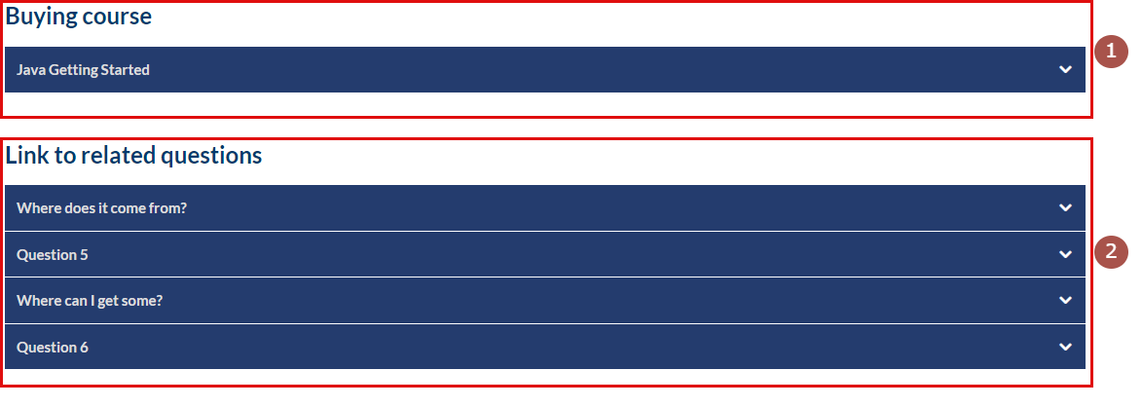

**Image- 1.11.1.2: Faq Section In Client**

* + Number 1 in **Image- 1.11.1.2** is Faq Section Order one, and number 2 in **Image- 1.11.1.2** is Faq Section Order Two.
  + And the Faq title will be placed at the top as shown in **Image- 1.11.1.2.**

### 1.11.2 Add A Faq Section

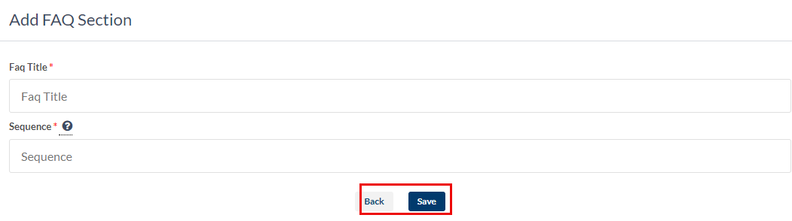

**Image- 1.11.2.1 Add A Faq Section**

* Admins must provide the following information to add a Faq Section.
  + Faq Title
  + Sequence
* The currency will be created if admins click the “**Create**” button.
* Clicking the “**Back**” button will redirect them to the list page.

### 1.11.3 Update A Faq Section

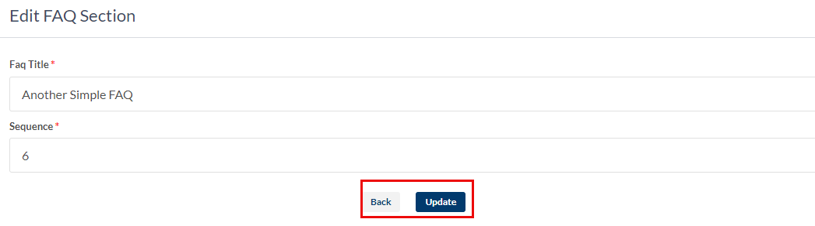

**Image- 1.11.3.1 Update A Faq Section**

* Admins can edit the following information about a Faq section.
  + Faq title
  + Sequence
* The Faq Section will be created if admins click the “**Update**” button.
* Clicking the “**Back**” button will redirect them to the list page.

## 1.12 Frequently Asked Questions

### 1.12.1 Faqs List

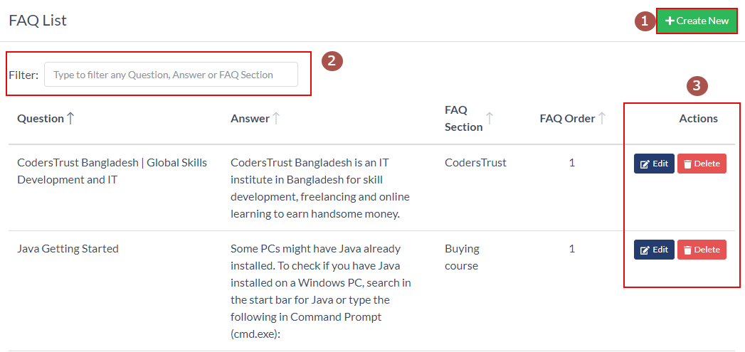

**Image- 1.12.1.1 Faqs List Page**

* All the FAQs will be listed here, shown in **Image- 1.12.1.1.**
* Admins can create a FAQ by clicking the “**Create New**” button.
* They can filter FAQs by question and answer.
* Admins can see the following information.
  + Question
  + Answer
  + Faq Section
  + Faq Order
  + Actions
    - **Edit,** clicking this button will redirect to the Edit page. See 1.12.3 Update A Faq
    - **Delete;** clicking this button will delete that faq and open a confirmation pop-up window. Admins must click the “**Ok**” button to delete it.



**Image- 1.12.1.2: Faq In Client**

* + Number 1 in **Image- 1.12.1.2** is Faq Section Order one, and number 2 in **Image- 1.12.1.2** is Faq Section Order Two.
  + And the Faq title will be placed at the top as shown in **Image- 1.12.1.2.**
  + Under every Faq Section, Frequently Asked Questions and answers will be placed.

### 1.12.2 Add A FAQ

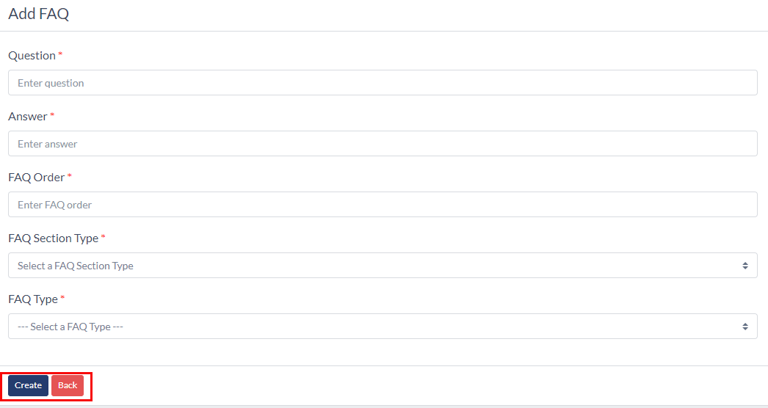

**Image- 1.12.2.1 Add A FAQ**

* Admins must provide the following information to add a FAQ and Answers.
  + Question
  + Answer
  + FAQ Order
  + Faw Section Type
  + Faq Type
* The FAQ will be created if admins click the “**Create**” button.
* Clicking the “**Back**” button will redirect them to the list page.

### 1.12.3 Update A FAQ

### 

**Image- 1.12.3.1 Add A Currency**

* Admins can edit the following information about a FAQ.
  + Question
  + Answer
  + FAQ Order
  + Faw Section Type
  + Faq Type
* The FAQ will be created if admins click the “**Update**” button.
* Clicking the “**Back**” button will redirect them to the list page.

## 1.13 Badges

### 1.13.1 Badge List

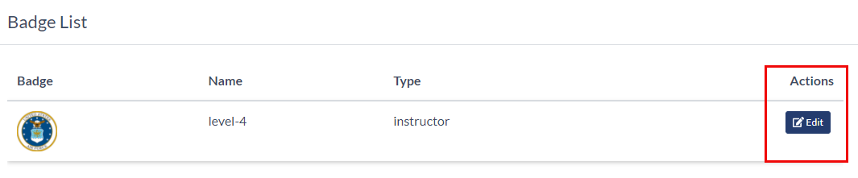

**Image- 1.13.1.1 Badge List Page**

* All the Badges will be listed here, shown in **Image- 1.13.1.1.**
* Admins can see the following information.
  + Badge Icon
  + Badge Name
  + Badge Type
  + Actions
    - **Edit**. If admins click the “**Edit**” button, they will redirect to the edit page. See 1.13.2 Edit Badge.

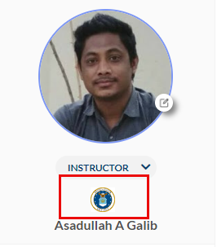

**Image- 1.13.1.2: Badge Placement In Client**

* The Badge will show on the Instructor profile page in the client app as shown in **Image- 1.13.1.2.**

### 1.13.2 Edit Badge

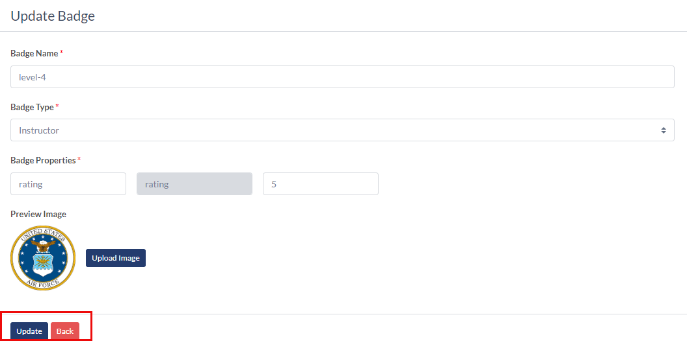

**Image- 1.13.2.1 Edit Badge**

* Admins can edit the following information about a Badge.
  + Badge Name
  + Badge Type
  + Badge Properties
  + Badge Image
* The Badge will be created if admins click the “**Update**” button.
* Clicking the “**Back**” button will redirect them to the list page.

## 1.14 News

### 1.14.1 News List

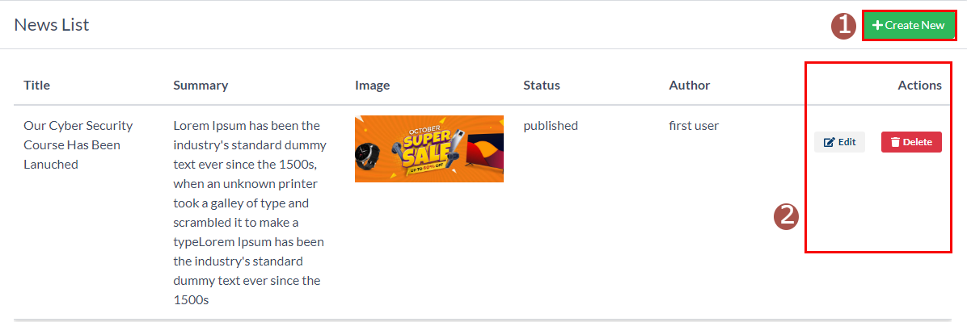

**Image- 1.14.1.1 Badge List Page**

* All the news will be listed here, shown in **Image- 1.14.1.1.**
* Admins can create news by clicking the “**Create New**” button in **Image- 1.14.1.1.**
* Admins can see the following information about the news
  + Title
  + Summary
  + Image
  + Status
  + Author
  + Actions
    - **Edit,** clicking this button will redirect to the Edit page. See 1.14.3 Update A News
    - **Delete;** clicking this button will delete that news and open a confirmation pop-up window. Admins must click the “**Ok**” button to delete it.

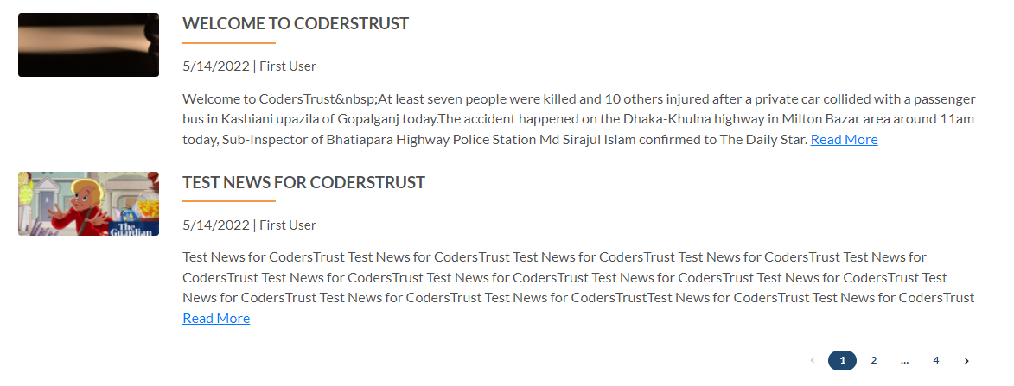

**Image- 1.14.1.2: News Placement In Client**

* The news will show on the News page in the client app as shown in **Image- 1.14.1.2.**

### 1.14.2 Add A News

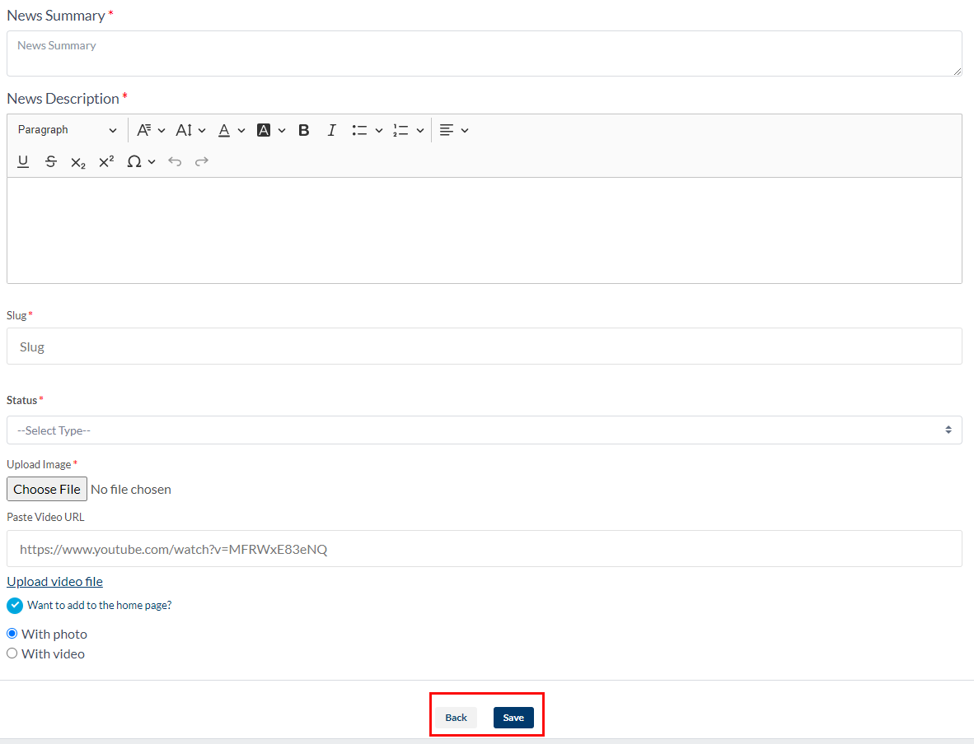

**Image- 1.14.2.1 Add A News**

* Admins must provide the following information to add news.
  + NewsTitle
  + News Summary
  + News Description
  + Slug. Slug will be automatically updated while typing the title. But admins can always change the slug.
  + Status
    - Published
    - Unpublished
  + Upload Image
  + Upload Video.
    - Admins can upload a video or just paste any youtube video URL here.
  + Want To Add To The Home Page.
    - If admins want to add that news to the home page, they need to click it.
    - After clicking, they must select between the photo or video they want to see on the homepage with the news.
* The news will be created if admins click the “**Create**” button.
* Clicking the “**Back**” button will redirect them to the list page.

### 1.14.3 Update A News

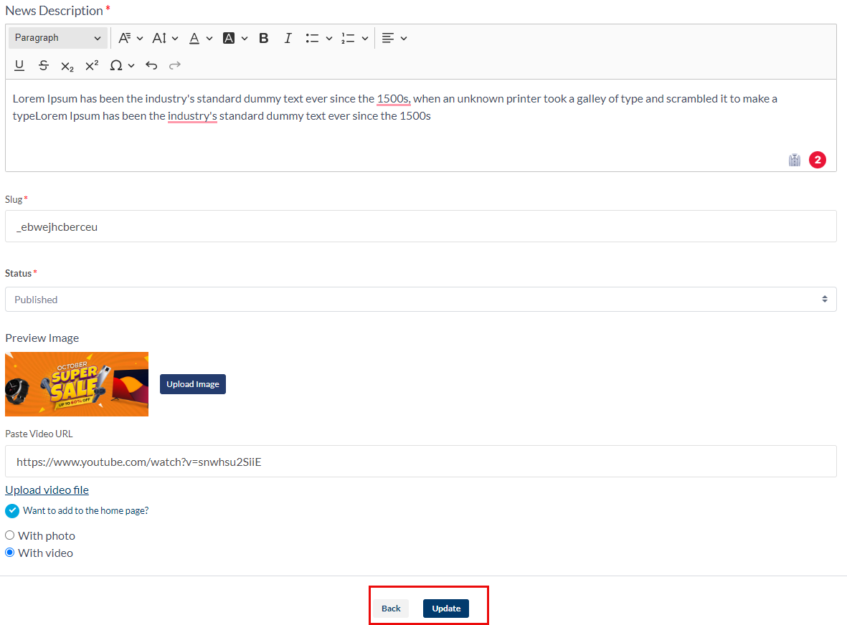

**Image- 1.14.3.1 Update A News**

* Admins can edit the following information about News.
  + NewsTitle
  + News Summary
  + News Description
  + Slug
  + Status
    - Published
    - Unpublished
  + Upload Image
  + Upload Video.
  + The news will be created if admins click the “**Update**” button.
  + Clicking the “**Back**” button will redirect them to the list page.

## 1.15 Content Management

### 1.15.1 Home

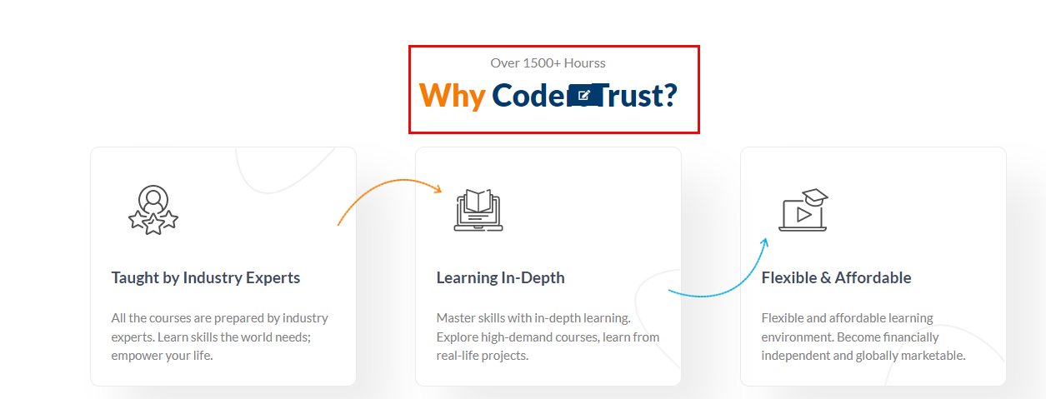

**Image- 1.15.1.1: Home Page Text Edit**

* Admins can change some sections’ text and images.
* If admins hover over the text, they will see an “**Edit**” button, as shown in **Image- 1.15.1.1.**

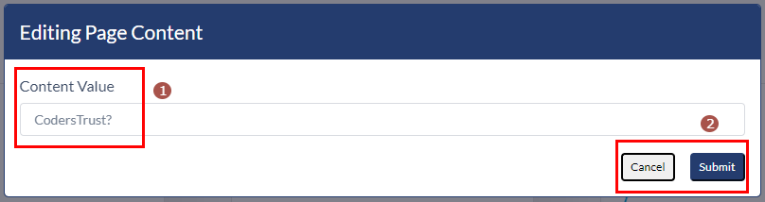

**Image- 1.15.1.2: Text Editing Window**

* + Admins can change the text from the “**content value**” field, shown in number 1 in **Image- 1.15.1.2.**
  + They must click the “**Submit**” button to see the changes.
  + Clicking the “**Cancel**” button will cancel the changes.
* Admins can change the text in the following section
  + Why CodersTrust?
  + Best Selling Courses
  + Live Online Courses
  + Become an Instructor
  + Upcoming Global Revenue Courses
  + Our Focus On You
  + Join Our Community
  + Features and Values
  + Success Story
  + Partners & Accreditations
  + Subscribe Newsletter

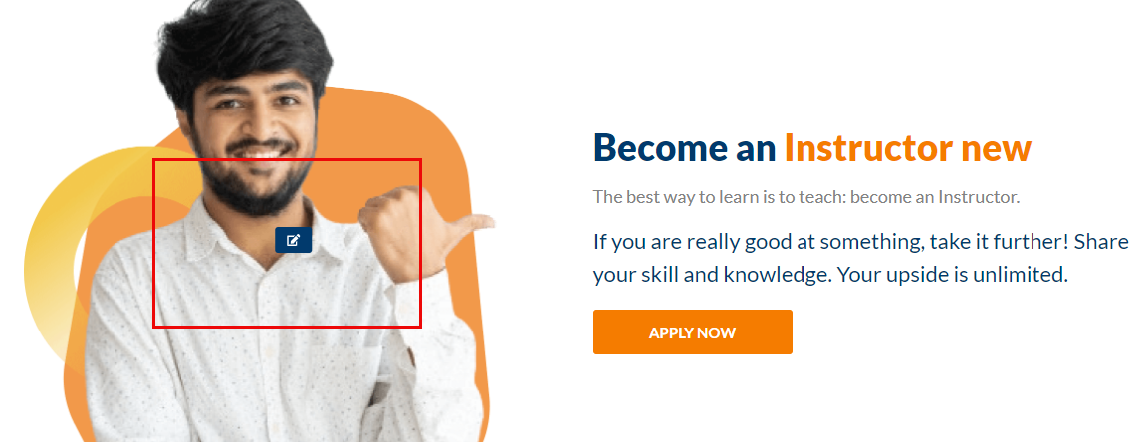

**Image- 1.15.1.3: Home Page Photo Edit**

* If admins hover over the image, they will see an “**Edit**” button, as shown in **Image- 1.15.1.3.**

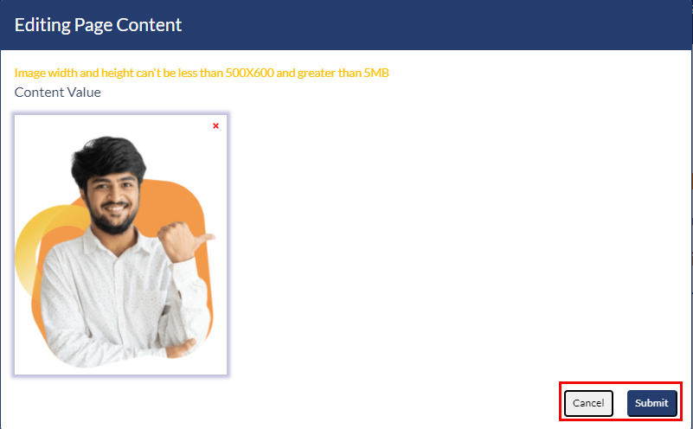

**Image- 1.15.1.4: Photo Editing Window**

* + Admins can change the photo by removing the image and uploading a new photo, shown in **Image- 1.15.1.4.**
  + They must click the “**Submit**” button to see the changes.
  + Clicking the “**Cancel**” button will cancel the changes.
* Admins can change the photos in the following section
  + Live Online Courses
  + Become an Instructor
  + Success Story
  + Partners & Accreditations
  + Subscribe Newsletter
* Admins must click the “**Publish Content**” to save the changes to the client.

## 1.16 Exam And Sales Report

### 1.16.1 Instructor Search

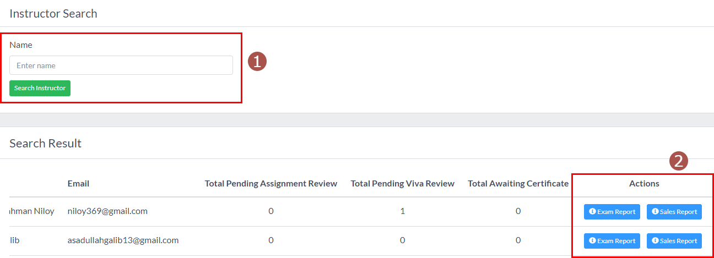

**Image- 1.16.1.1: Home Page Text Edit**

* Admins can see the instructor’s report from this section, shown in **Image- 1.16.1.1.**
* Number 1 in **Image- 1.16.1.1,** they can search for any admin.
* They must click the “**Search Instructor**” button to see the instructor report.
* In the search result, admins can see the following information.
  + Name
  + Email
  + Total Pending Assignment Review
  + Total Pending Viva Review
  + Total Awaiting Certificate
  + Actions
    - Exam Report. See 1.16.2 Exam Report
    - Sales Report. See 1.4.3 Sales Report

### 1.16.2 Exam Report

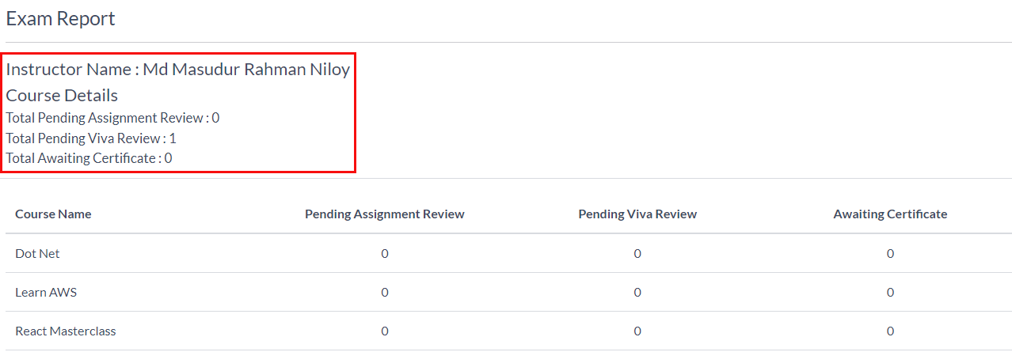

**Image- 1.16.2.1: instructor’s Exam Report**

* If admins click the ”**Exam Report**”, shown in number 2 in **Image- 1.16.1.1.** They will redirect to this page.
* They will see highlights information about the instructor at the top.
  + Instructor Name
  + Course Details
  + Total Pending Assignment Review
  + Total Pending Viva Review
  + Total Awaiting Certificate.
* Furthermore, In the table, admins can see the following information.
  + Course Name
  + Pending Assignment Review
  + Pending Viva Review
  + Awaiting Certificate

## 1.17 Course Report

### 1.17.1 Search Course

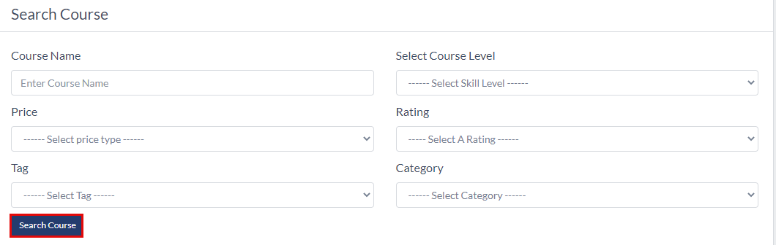

**Image- 1.17.1.1: Search Course**

* Admins can search a course to see its report, shown in **Image- 1.16.1.1.**
* They can search by the following parameters.
  + Course Name
  + Select Course Level
    - Beginner
    - Intermediate
    - Expert
  + Price
    - Free
    - Paid
  + Rating
  + Tag
  + Category
* Admins must click the “**Search Course**” to see the result.

### 1.17.2 Search Course Result

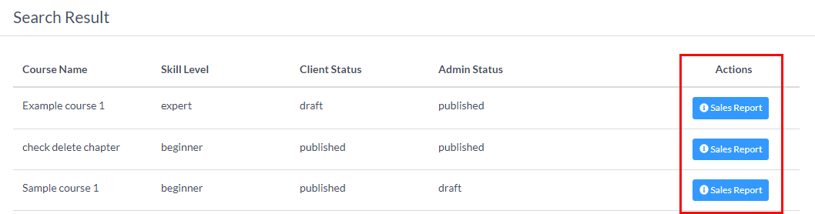

**Image- 1.17.2.1: Search Course**

* After clicking the “**Search Course**” button, the result will come here.
* Admins can see the following fields.
  + Course Name
  + Skill Level
  + Client Status
  + Admin Status
  + Actions
    - Sales Report. See 1.4.3 Sales Report

## 1.18 Coupon Usages

### 1.18.1 Coupon Report

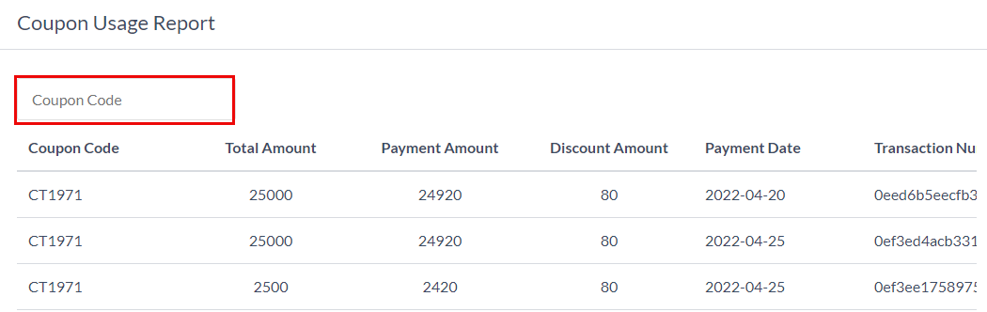

**Image- 1.18.1.1: Coupon Report**

* Admins can search a coupon to see its usage and report, shown in **Image- 1.18.1.1.**
* They will see the following parameters.
  + Coupon Code
  + Total Amount
  + Payment Amount
  + Discount Amount
  + Payment Date
  + Transaction Number

## 1.19 Export Report

### 1.19.1 Export Sales Report

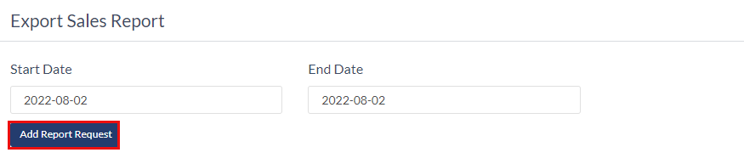

**Image- 1.18.1.1: Export Sales Report**

* Admins can request reports in between any day.
* They have to select the start date
* They have to choose the end date
* Admins must click the “**Add Report Request.**”

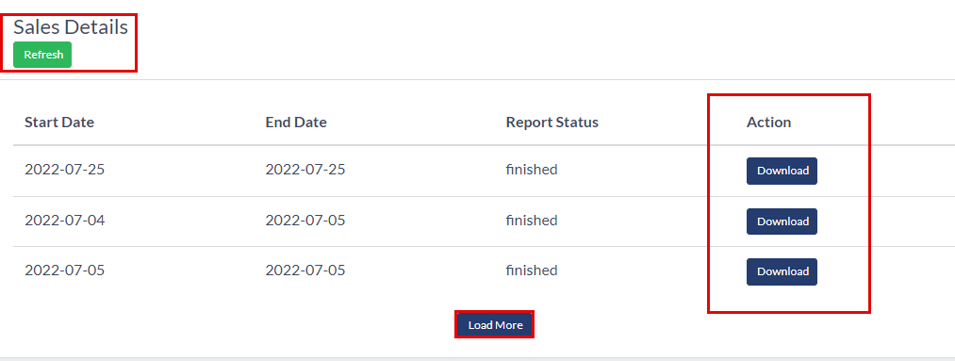

**Image- 1.18.1.2: Sales Details**

* Admins can refresh the page by clicking the “**Refresh**” button.
* They will see the following information about the report.
  + Start Date
  + End Date
  + Report Status
  + Action
    - **Download**. Clicking this button will download the report in an excel document.
  + **Load More.** Clicking this button will load more reports.

## 1.20 Payment

### 1.20.1 Gateway

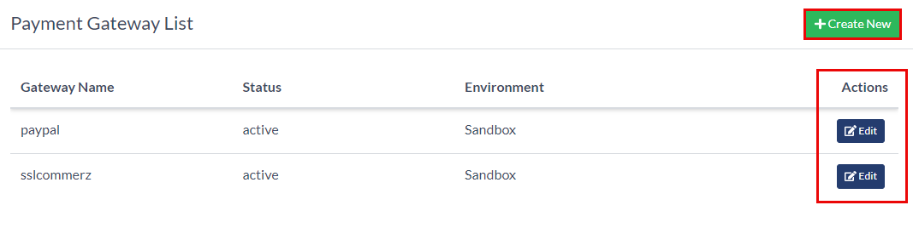

**Image- 1.20.1.1 Badge List Page**

* All the payment gateway will be listed here, shown in **Image- 1.20.1.1.**
* Admins can create a gateway by clicking the “**Create New**” button in **Image- 1.20.1.1.**
* Admins can see the following information about the news
  + Gateway Name
  + Status
  + Environment
  + Actions
    - **Edit,** clicking this button will redirect to the Edit page. See 1.20.3 Update A News

### 1.20.2 Create A Gateway

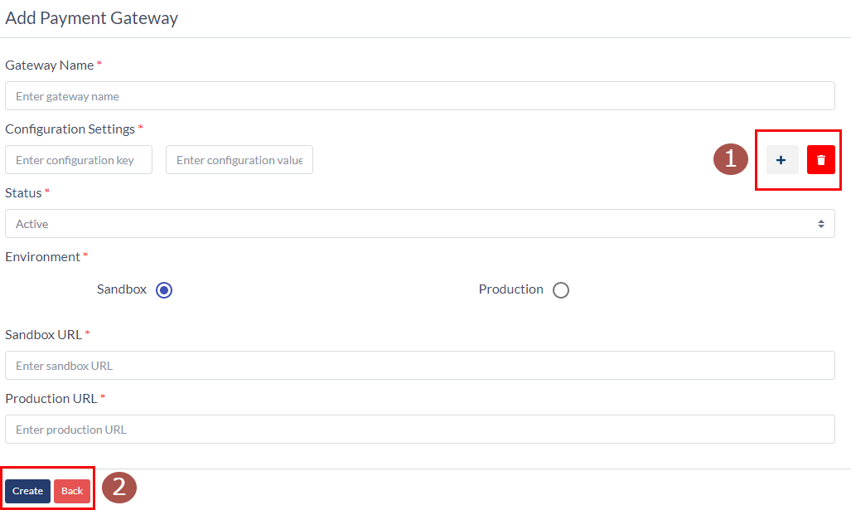

**Image- 1.20.2.1 Add A Gateway**

* Admins will redirect to this page after clicking the “**Create New**” button, shown in **Image- 1.20.1.1.**
* Admins must provide the following information to add Gateway.
  + Gateway Name
  + Configuration Settings
    - * Configuration Key
      * Configuration Value
    - Admins can add Configuration Settings by clicking the “**Plus**” button.
    - They can delete Configuration Settings by clicking the “**Delete**” button.
  + Status
    - Active
    - Inactive
  + Environment
    - Sandbox
    - Production
  + Sandbox URL
  + Production URL
* The news will be created if admins click the “**Create**” button.
* Clicking the “**Back**” button will redirect them to the list page.

### 1.20.3 Update A News

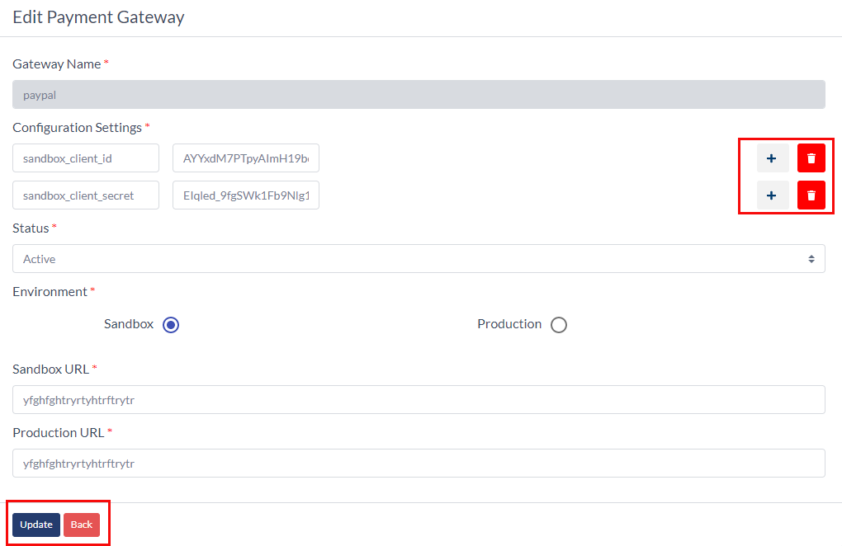

**Image- 1.20.3.1 Update A Gateway**

* Admins will redirect to this page after clicking the “**Edit**” button.
* Admins can edit the following information.
  + Gateway Name
  + Configuration Settings
    - * Configuration Key
      * Configuration Value
    - Admins can add Configuration Settings by clicking the “**Plus**” button.
    - They can delete Configuration Settings by clicking the “**Delete**” button.
    - But there must be at least one Configuration Settings.
  + Status
    - Active
    - Inactive
  + Environment
    - Sandbox
    - Production
  + Sandbox URL
  + Production URL
  + The news will be created if admins click the “**Update**” button.
  + Clicking the “**Back**” button will redirect them to the list page.

## 1.21 Subscriber

### 1.21.1 Subscriber List

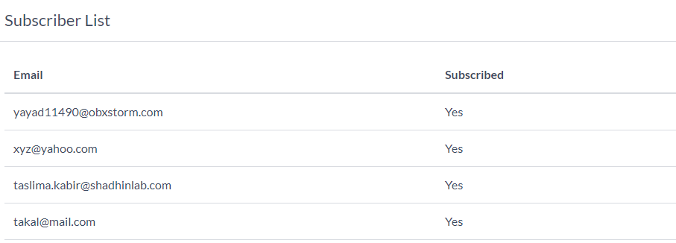

**Image- 1.21.1.1 Subscriber List Page**

* The subscriber's list will be here, shown in **Image- 1.21.1.1.**
* Admins can see the following fields of subscribers.
  + Email
  + Subscribe
    - Yes
    - No

## 1.22 Help And Support

### 1.22.1 Supports

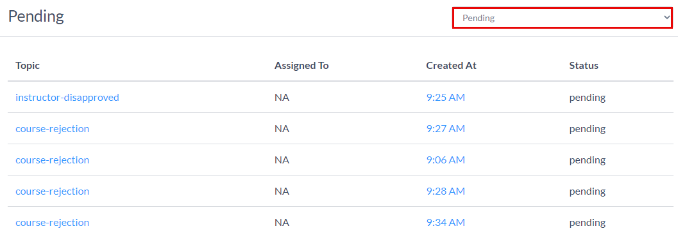

**Image- 1.22.1.1 Support List Page**

* The Support requests from the users will be listed here, shown in **Image- 1.22.1.1.**
* Admins can filter the list with
  + Pending
  + Close
  + Reopen
  + Customer Action Required
  + Admin action required
* Admins can see the following fields of the support list.
  + Topic
  + Assigned To
  + Created At
  + Status
* The content of the topic field is clickable. If admins click on any topic, they will redirect to the Ticket Details Page of that support. See 1.22.2 Ticket Details

### 1.22.2 Ticket Details

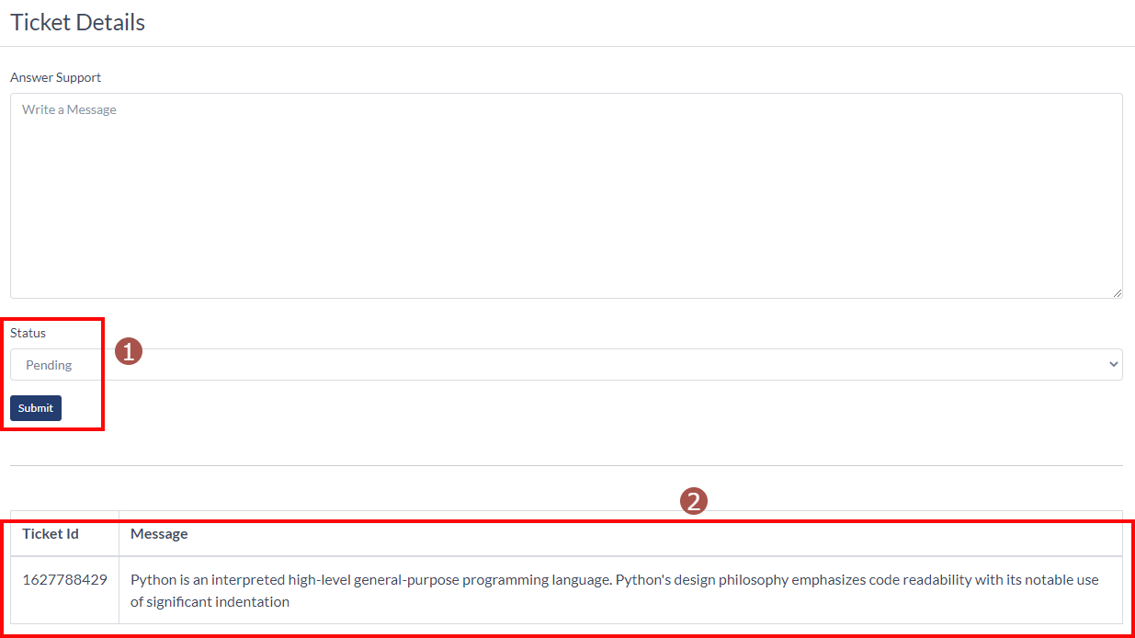

**Image- 1.22.2.1 Ticket Details Page**

* On the Ticket Details Page, admins can answer the support.
* Admins can see the ticket Id and Message, shown in number 2 in **Image- 1.22.2.1.**
* They have to write the answer in the “**Answer Support**” field.
* They can change the status to
  + Pending
  + Close
  + Reopen
  + Customer Action Required
  + Admin action required
* After answering the support and changing the status, they must click the “**Submit**” button.

## 1.23 Update A Course

### 1.23.1 Initial Setup

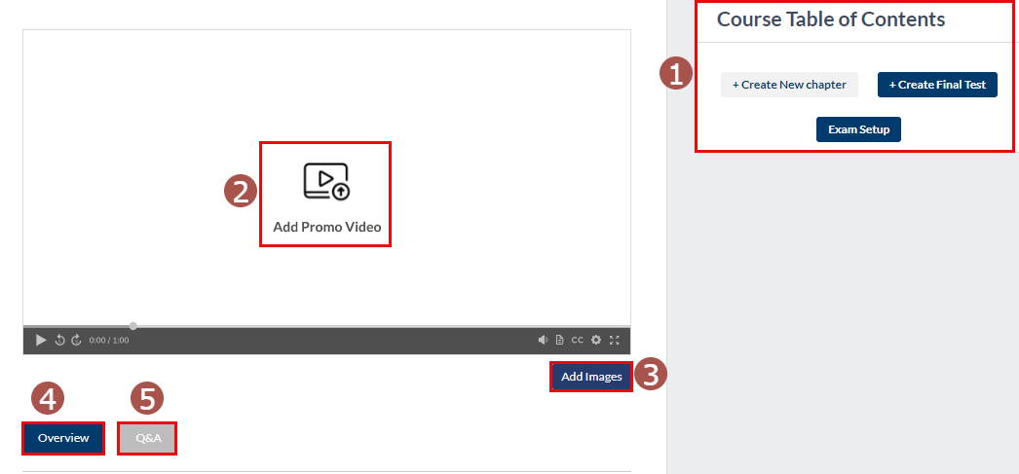

**Image- 1.23.1.1: Initial Setup Section**

* Admins will come to this page if they click the “Edit” button from the **Image- 1.4.2.1** and after creating the course.
* Number 1 in **Image- 1.23.1.1** admins can see three buttons.
  + **Create A New Chapter.** If admins click this button, they can create a new chapter for the course. See
  + **Create A Final Test**. If admins click this button, they can make a final test. See 1.23.6 Create Final Test
  + **Exam Setup**. If they click this button, they can set up the exam format. See 1.23.3 Exam Setup
* Number 2 in **Image- 1.23.1.1** admins can upload a promo video for the course if they click that button.

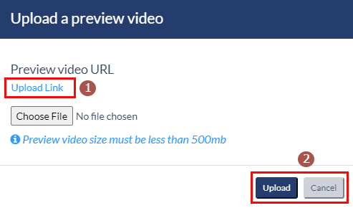

**Image- 1.23.1.2: Preview Video URL**

* + They can upload a video or paste a youtube video URL by clicking the “**Upload Link**” button, shown in number 1 in **Image- 1.23.1.2.**
  + Admins must click the “**Upload**” button to save the video.
  + If they click the “**Cancel**” button, the video will not save.
* Number 3 in **Image- 1.23.1.1** admins can upload a cover photo and thumbnail photo.

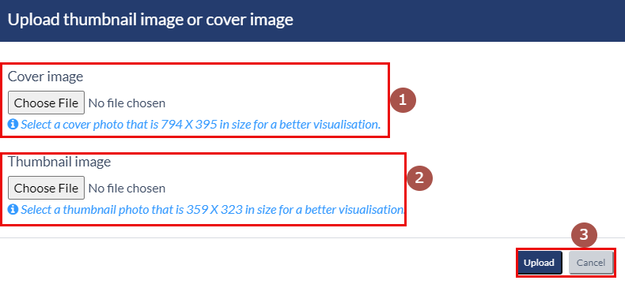

**Image- 1.23.1.3: Cover And Thumbnail Image Upload**

* + Admins can upload the Cover image, shown in number 1 in **Image- 1.23.1.3**
  + They can upload the Thumbnail image, shown in number 2 in **Image- 1.23.1.3**
  + Admins must click the “**Upload**” button to save the video.
  + If they click the “**Cancel**” button, the video will not save.
* Number 4 in **Image- 1.23.1.1** admins can update the overview section of the course. See 1.23.2 Overview Section
* Number 5 in **Image- 1.23.1.1** admins can update the Q&A section of the course. See 1.23.8 Q&A Section.

### 1.23.2 Overview Section

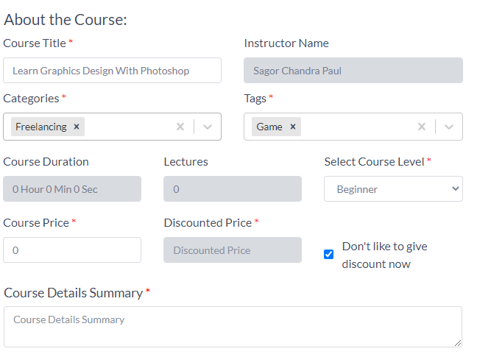

**Image- 1.23.2.1: Overview Section**

* In this section, admins can update some information about the course.
* Admins can change the following fields
  + **Course Title**
  + **Categories.** A maximum of three categories can be added.
  + **Tags**. A maximum of three Tags can be added.
  + **Course Level**
    - Beginner
    - Intermediate
    - Expert
  + **Course Price**
  + **Discount Price**. This field can be edited if only admins uncheck the “Don’t like to give discount now” button.
  + **Course Details Summary**.
* **Course Details Section:**

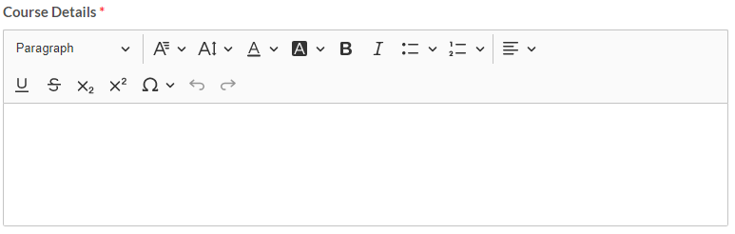

**Image- 1.23.2.2: Course Details Section**

* + Admins must fill the “**course details**” section. Without this, the course can not be saved.
  + They can customize their write-ups with the text editor tool.
* **Requirements Section:**

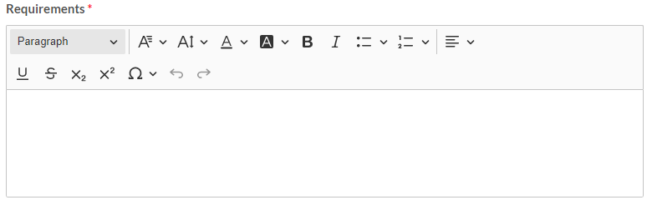

**Image- 1.23.2.2: Course Requirements Section**

* + Admins must fill the course “**requirements**” section. Without this, the course can not be saved.
  + They can customize their write-ups with the text editor tool.
* **Items Will Learn Section:**

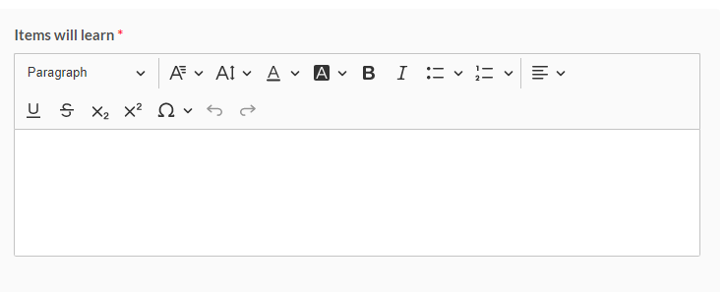

**Image- 1.23.2.3: Items Will Learn Section**

* + Admins must fill the “**items will learn**” section. Without this, the course can not be saved.
  + They can customize their write-ups with the text editor tool.
* **Course Includes Section:**

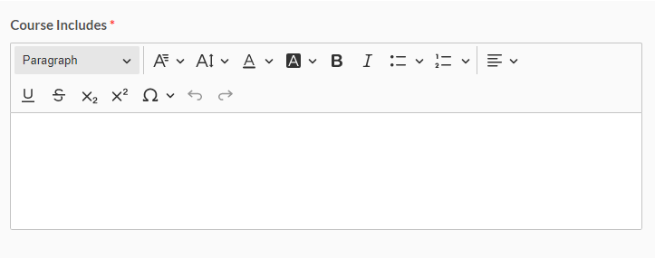

**Image- 1.23.2.4: Course Includes Section**

* + Admins must fill the “**course includes**” section. Without this, the course can not be saved.
  + They can customize their write-ups with the text editor tool.
* **Note Section:**

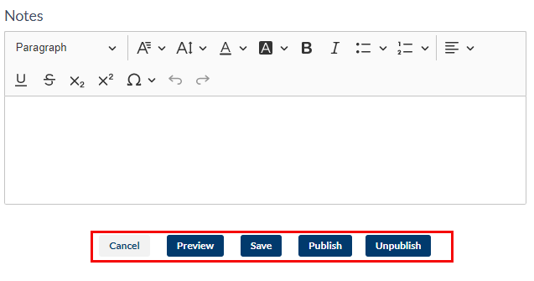

**Image- 1.23.2.5: Course Note Section**

* + Admins can fill the “**Notes**” section. Without this, the course can not be saved.
  + They can customize their write-ups with the text editor tool.
  + There are five buttons under the Notes section.
    - **Cancel.** Clicking this button will cancel all the changes and redirect to the course search page.
    - **Preview.** This will show the preview of the course details page if they click on it. Admins will get an idea of how all sections look on the course details page.
    - **Save.** If admins click this button, the changes will be saved. However, all the asterisk fields must be filled before saving.
    - **Publish.** Clicking this button will publish the course for the client’s students. But before that, if any changes happen to this page, admins must save it.
    - **Unpublish.** This will unpublish the course. Nonetheless, the course must be published; otherwise, the “**Unpublished**” button will be disabled.
      * The Unpublish course will disappear from the client application.
      * Unregister users and students can not find the unpublish by searching and course list page.
      * Students who enrolled in the course while it was published only they can see the course on their My Learning page.

### 1.23.3 Exam Setup

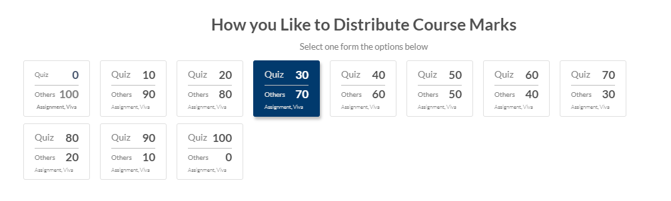

**Image- 1.23.3.1: Exam Setup**

* After clicking the “**Exam Setup**” button, shown in number 1 in **Image- 1.23.1.1,** this pop-up will open.
* From here, admins can choose any one setup for the course.
* The setups are
  + Quiz = 0, Assignment, viva = 100
  + Quiz = 10, Assignment, viva = 90
  + Quiz = 20, Assignment, viva = 80
  + Quiz = 30, Assignment, viva = 70
  + Quiz = 40, Assignment, viva = 60
  + Quiz = 50, Assignment, viva = 50
  + Quiz = 60, Assignment, viva = 40
  + Quiz = 70, Assignment, viva = 30
  + Quiz = 80, Assignment, viva = 20
  + Quiz = 90, Assignment, viva = 10
  + Quiz = 100, Assignment, viva = 0

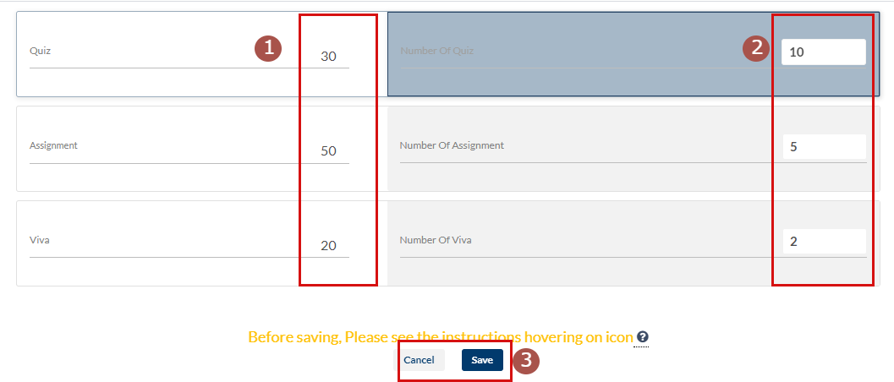

**Image- 1.23.3.2: Weight Distribution**

* According to the setup, admins must set the weight for Quiz, Assignment, and Viva, shown in number 1 in **Image- 1.23.3.2.**
* Admins must choose the quantity of each exam. Such as quiz, assignment, and viva, shown in number 2 in **Image- 1.23.3.2.**
* The exam setup will be saved if admins click the “**Save**” button.
* Clicking the “**Cancel**” button will cancel the changes.
* **Note:** After publishing the course:
  + Admin can’t add new items such as viva, assignment, and quiz, which they haven’t added yet.
  + They can’t remove any items which they have already added.
  + Admins can only edit the weight of those items, shown in number 1 in **Image- 1.23.3.2.**
  + They can’t edit the number of the quiz, assignments, and viva.

### 1.23.4 Create New Chapter

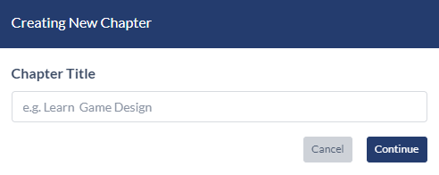

**Image- 1.23.4.1: Exam Setup**

* After clicking the “**Create New Chapter**” button, shown in number 1 in **Image- 1.23.1.1,** this pop-up will open.
* Admins must type the Chapter Title for the new chapter.
* They must click the “**Continue**” button to save the chapter title, and after clicking the button, a new pop-up window will appear for creating the lesson. See 1.23.5 Create Lesson.
* Clicking the “**Cancel**” button will cancel the creating Chapter.

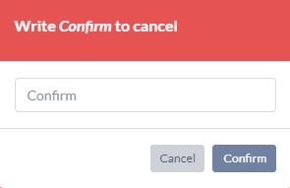

**Image- 1.23.4.2: Confirm Cancel**

* If admins type the title of the chapter and then click the “**Cancel**” button, this pop-up window will open for confirmation.
* Admins must type “**Confirm**” to confirm the cancellation.

### 1.23.5 Create Lesson

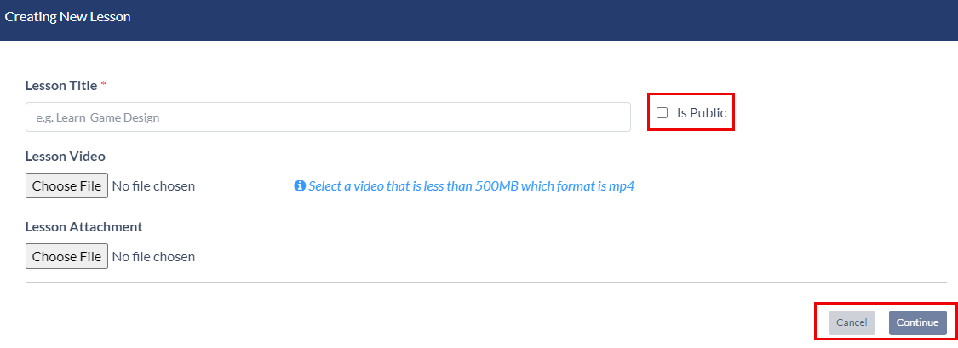

**Image-1.23.5.1: Create Lesson**

* Admins must provide the lesson title.
* They can make it a public video by clicking the “**Is Public**” button. Then the lesson video will be public, and students can watch that lesson without enrolling in it.
* Furthermore, admins can upload a lesson video and lesson attachment.
* They must click the “**Continue**” button to publish it, and a new pop-up window will appear for confirmation.

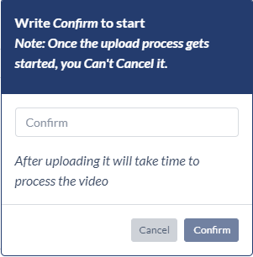

**Image- 1.23.5.2: Confirm Upload**

* Admins must type the “**Confirm**” for confirmation of creating a lesson.
* If admins click the “**cancel**” button, lesson creation will be cancelled.

### 1.23.6 Create Test

A pop-up window will open if admins click the “**Create Final Test**” button, as shown in number 1 in **Image- 1.4.2.1.**

* Admins can create tests for the students.
  + Quiz test
  + Assignment test
  + Viva test
* **Quiz Test**

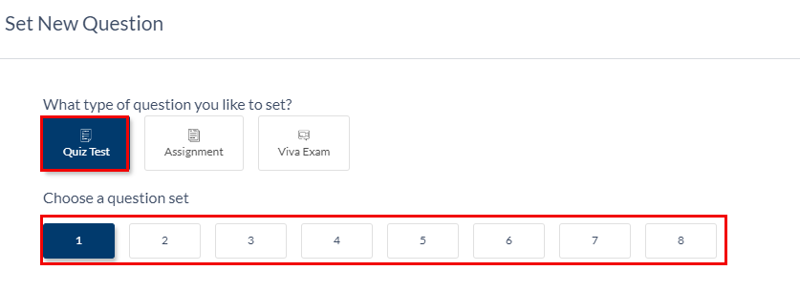

**Image- 1.23.6.1: Quiz Test Setup**

* + Admins must select the “**Quiz Test**” tab for the quiz.
  + They must select the question set.
    - There will be a total of 8 sets of questions.
    - For each set, the number of quizzes will be three times the set number.
    - For example,
      * set 1 will have 1X 3 = 3 quizzes
      * Set 2 will have 2X3 = 6 quizzes.
      * Set 8 will have 8X3 = 24 quizzes.

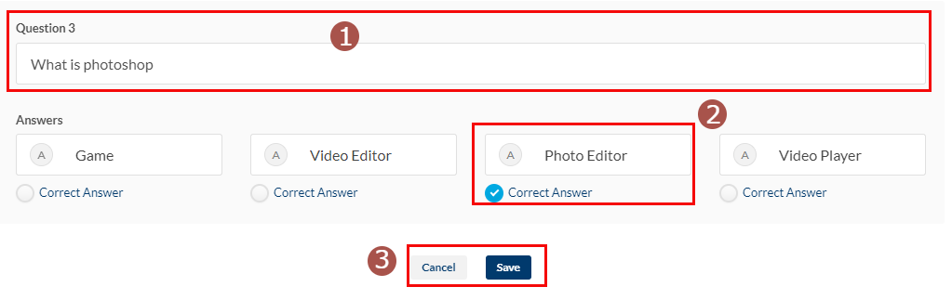

**Image- 1.23.6.2: Quiz Test Setup**

* + Admins must type the question for the quiz, shown in number 1 in **Image- 1.23.6.2.**
  + They must provide four possible answers and set the correct answers, shown in number 2 in **Image- 1.23.6.2.**
  + They must click the “**Save**” button to save the quiz.
  + Clicking the “**Cancel**” button will cancel the quiz creation.
* **Assignment Test**

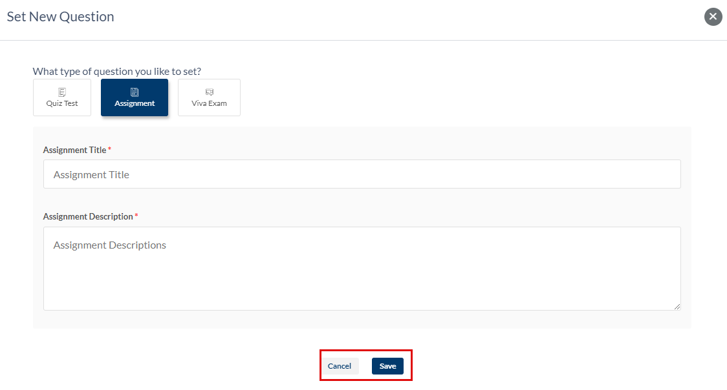

**Image- 1.23.6.3: Assignment Test Setup**

* + Admins must select the “**Assignment**” tab for the assignment test.
  + They must provide
    - Assignment Title
    - Assignment Description
  + They must click the “**Save**” button to save the assignment.
  + Clicking the “**Cancel**” button will cancel the assignment creation.
* **Viva Test**

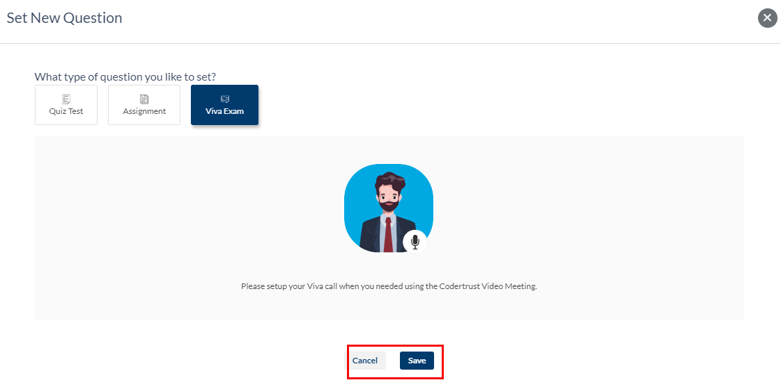

**Image- 1.23.6.3: Viva Test Setup**

* + Admins must select the “**Viva**” tab for the assignment test.
  + Admins must click the “**Save**” button to save the viva.
  + Clicking the “**Cancel**” button will cancel the viva creation.

### 1.23.7 Table Of Content

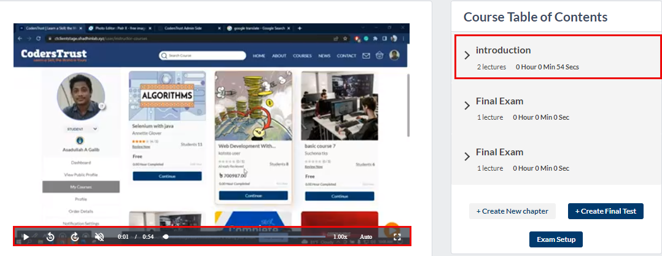

**Image- 1.23.7.1: Table Of Content**

* After creating the chapter and final test, the course table of content will look like this, shown in **Image- 1.23.1.1.**
* All lessons will shrink inside the chapter name. Admins must click the chapter name, and it will expand.
* On the left side of the Table of Contents is a video player. All lessons will be played here.

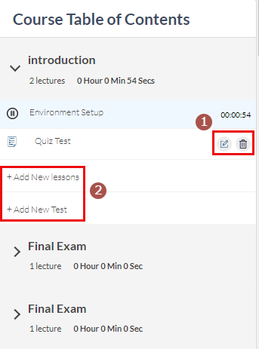

**Image- 1.23.7.2: Table Of Content**

* + If admins expand the chapter, they will see all lessons, quizzes, assignments, and viva inside it.
  + Admins can edit any test by clicking the edit button, shown in number 1 in **Image- 1.23.7.2**
  + They can delete any test by clicking the delete button, shown in number 1 in **Image- 1.23.7.2**
    - If admins delete any chapter, then all the lessons, quizzes, assignments, and viva inside it also be deleted.
    - Deleted chapters, lessons, quizzes, assignments, and viva will not be visible to admins, instructors, students, and unregistered users.
    - Deleted chapters, lessons, quizzes, assignments, and viva will not be visible in preview mode.
  + Admins can add new lessons by clicking the “**Add New Lessons**”; shown in number 2 in **Image- 1.23.7.2.** See 1.23.5 Create Lesson.
  + Admins can add new tests by clicking the “**Add New Test**”; shown in number 2 in **Image- 1.23.7.2.** See 1.23.6 Create Test

### 1.23.8 Q&A Section

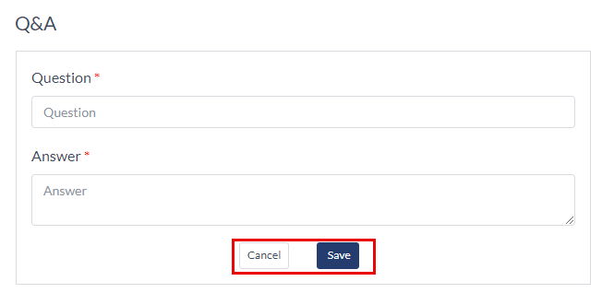

**Image- 1.23.8.1: Adding Q&A**

* Admins will come to this section after clicking the “**Q&A**” tab; see number 5 in **Image- 1.23.1.1.**
* Admins must type the question in the question field.
* They must type the answer in the answer field.
* If they click the “**Save**” button, the Q&A will be added.
* The Q&A will be cancelled if admins click the “**Cancel**” button.

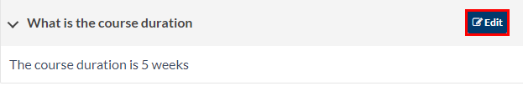

**Image- 1.23.8.2: Q&A List**

* After adding a Q&A, it will be added to the list.
* Admins can edit the Q&A by clicking the edit button, shown in number 2 in **Image- 1.23.8.2.**

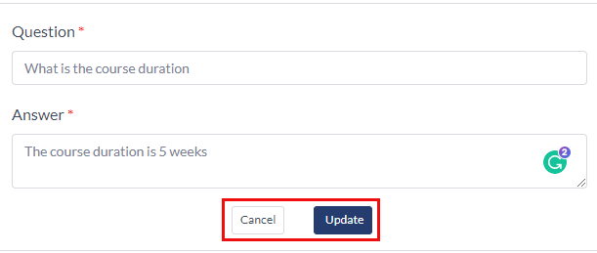

**Image- 1.23.8.3: Edit Q&A**

* The question and answer will automatically be filled.
* They can change the question and answer.
* If admins click the “**Update**” button, the Q&A will be updated.
* The Q&A update will be cancelled if admins click the “**Cancel**” button.

## 1.24 Roles

### 1.24.1 Roles List

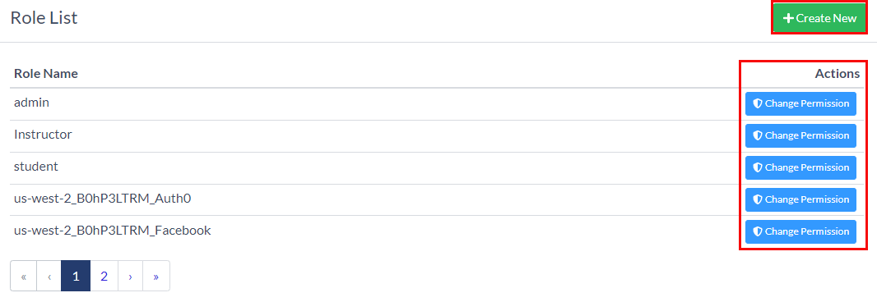

**Image- 1.13.1.1 Faqs List Page**

* All the Roles will be listed here, shown in **Image- 1.13.1.1.**
* Admins can create a Role by clicking the “**Create New**” button. See 1.24.2 Add A Role
* Admins can see the following information.
  + Role Name
  + Actions
    - **Change Permission**. A pop-up window will appear by clicking this, and admins can change permissions from there.

### 1.24.2 Add A Role

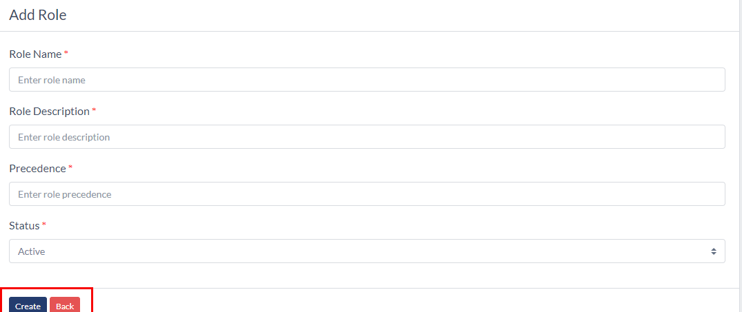

**Image- 1.13.2.1 Faqs List Page**

* Admins must provide the following information to add a Role.
  + Role Name
  + Role Description
  + Precedence
  + Status
* The Rolle will be created if admins click the “**Create**” button.
* Clicking the “**Back**” button will redirect them to the list page.

### 1.24.3 Update A Role

### 

**Image- 1.12.3.1 Update A Role**